1. Go to [www.languagetesting.com](http://www.languagetesting.com) and select your language:

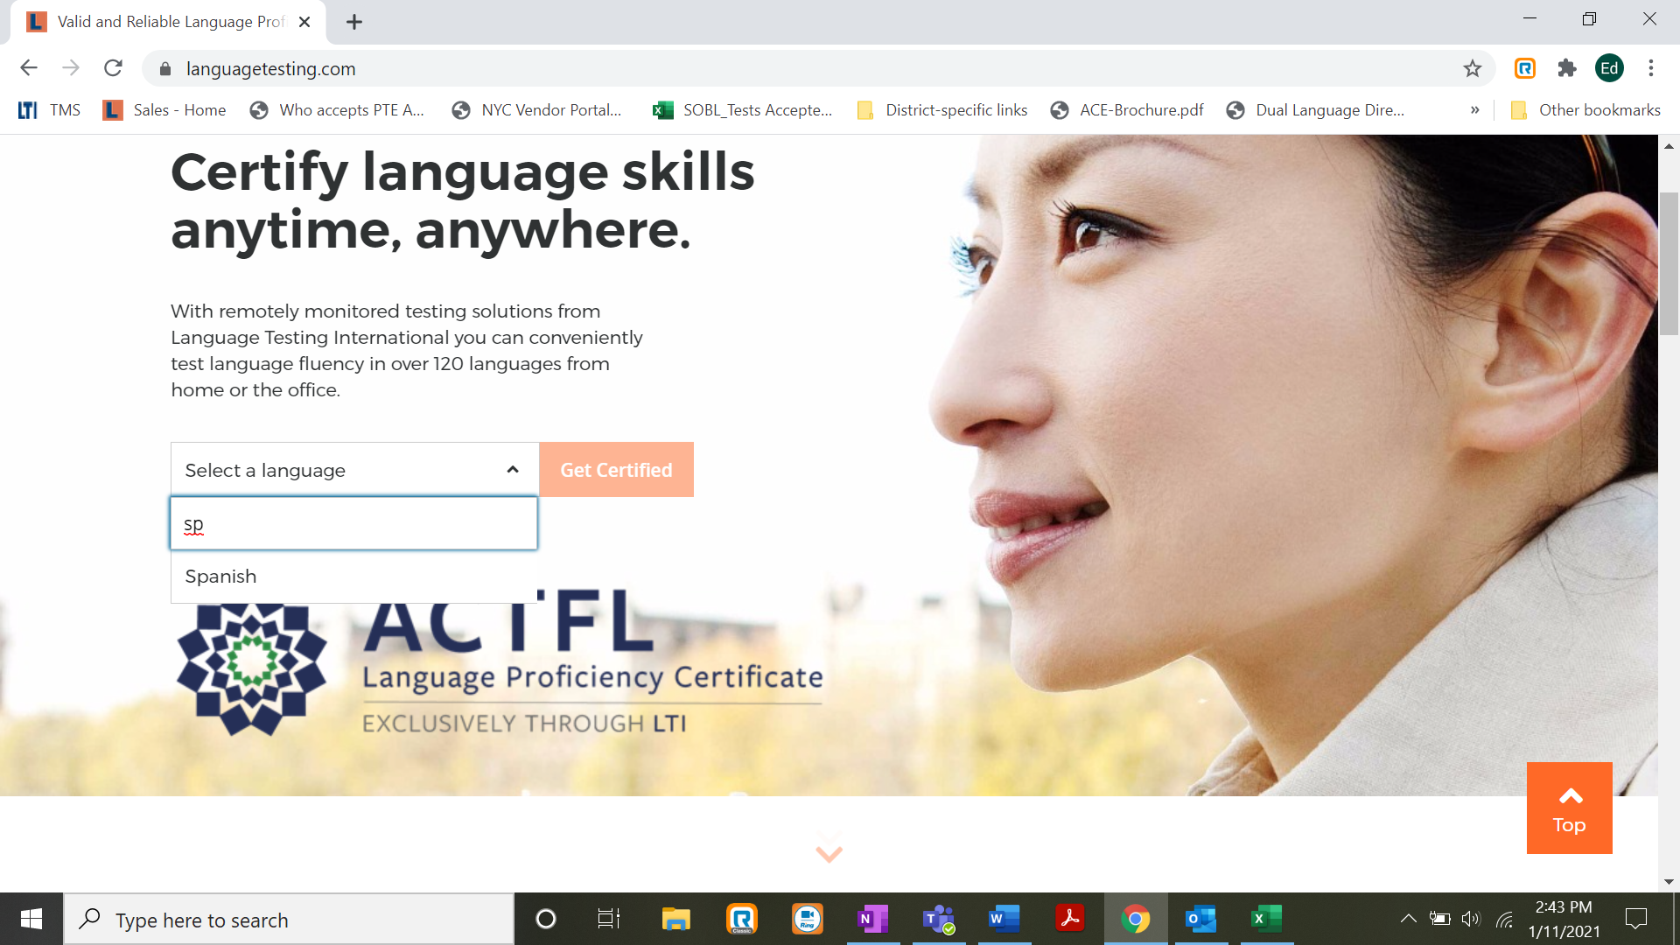

1. On the next screen, scroll down and click “Choose Test” in the “Programs with ACTFL requirements” box.

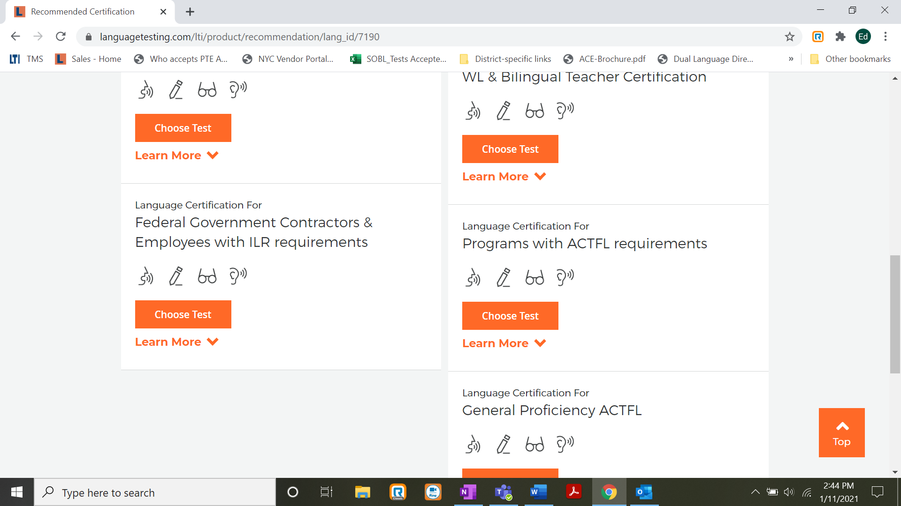

Enter “Boise State University Department of World Languages Spanish/French Placement Test,” being careful *not* to select “Boise State University World Language Department.”

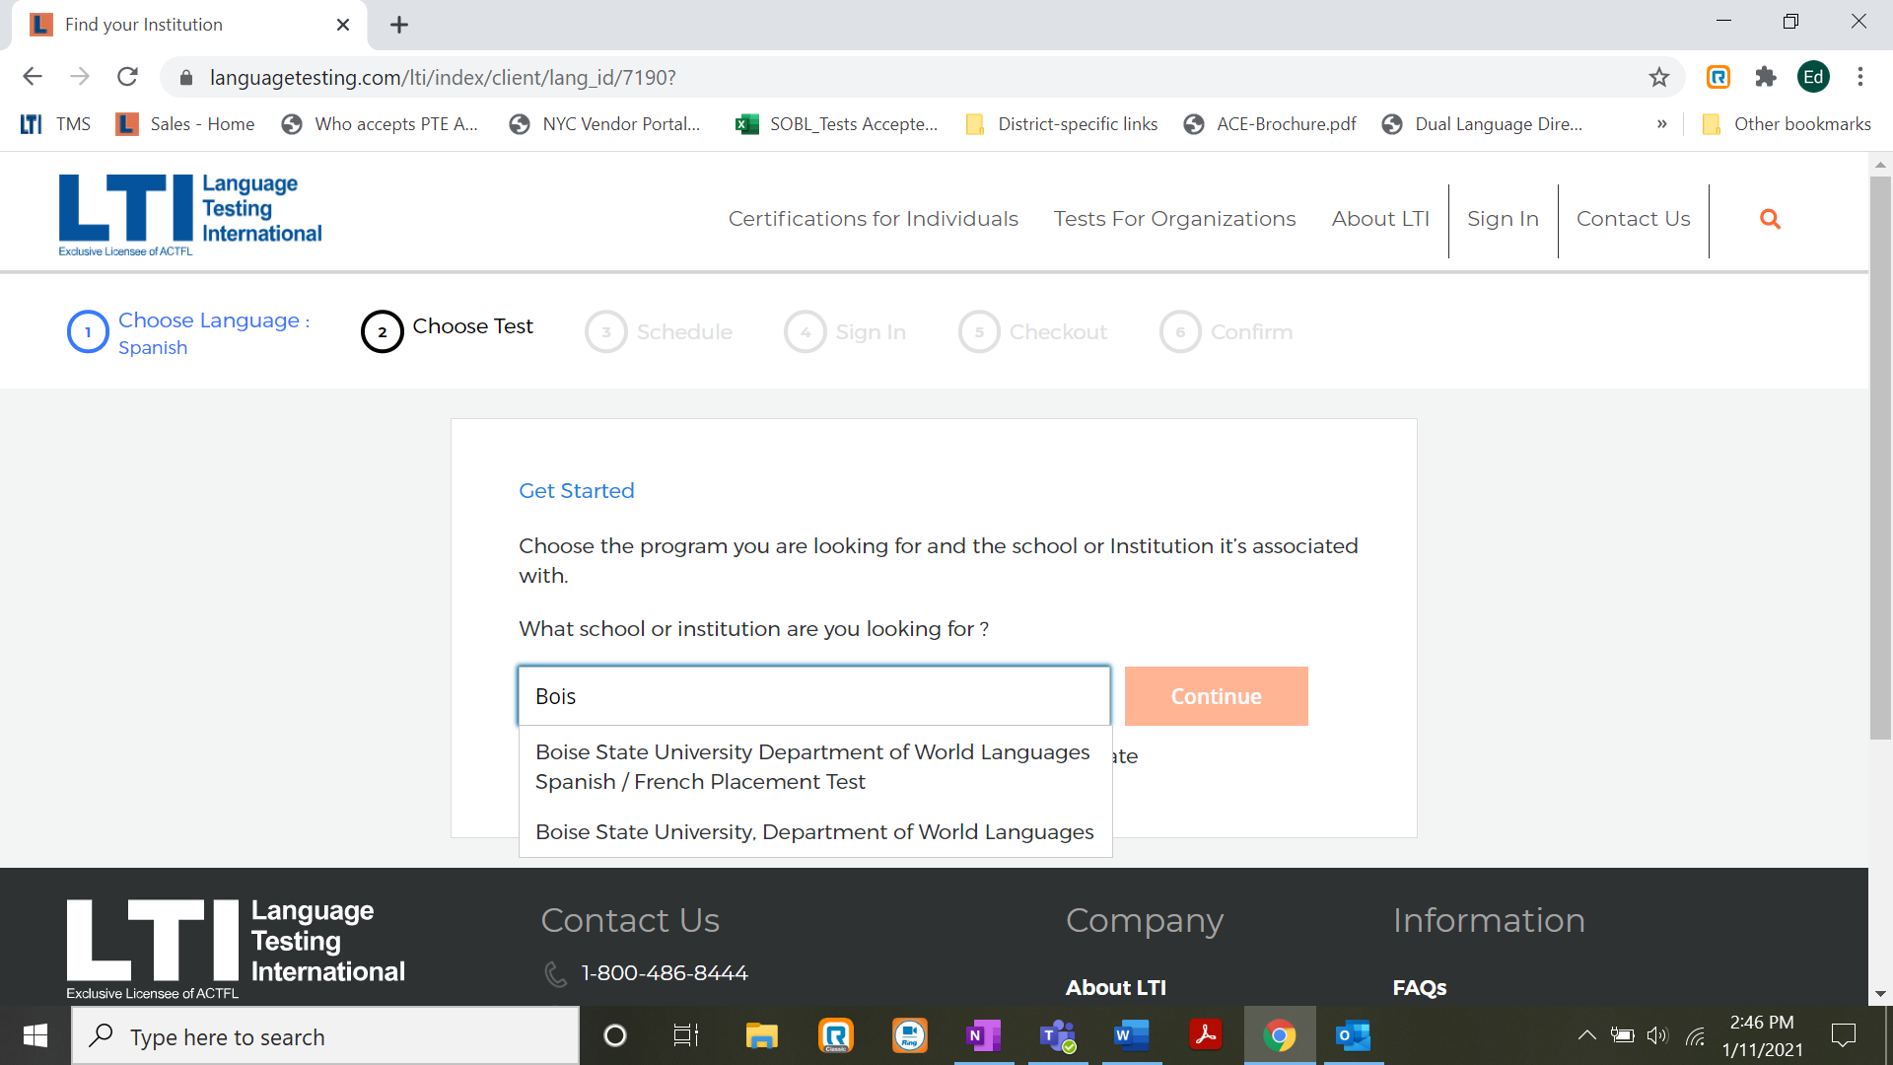

Then, you will see only one selection to make, “ACTFL Proficiency Placement Test.”

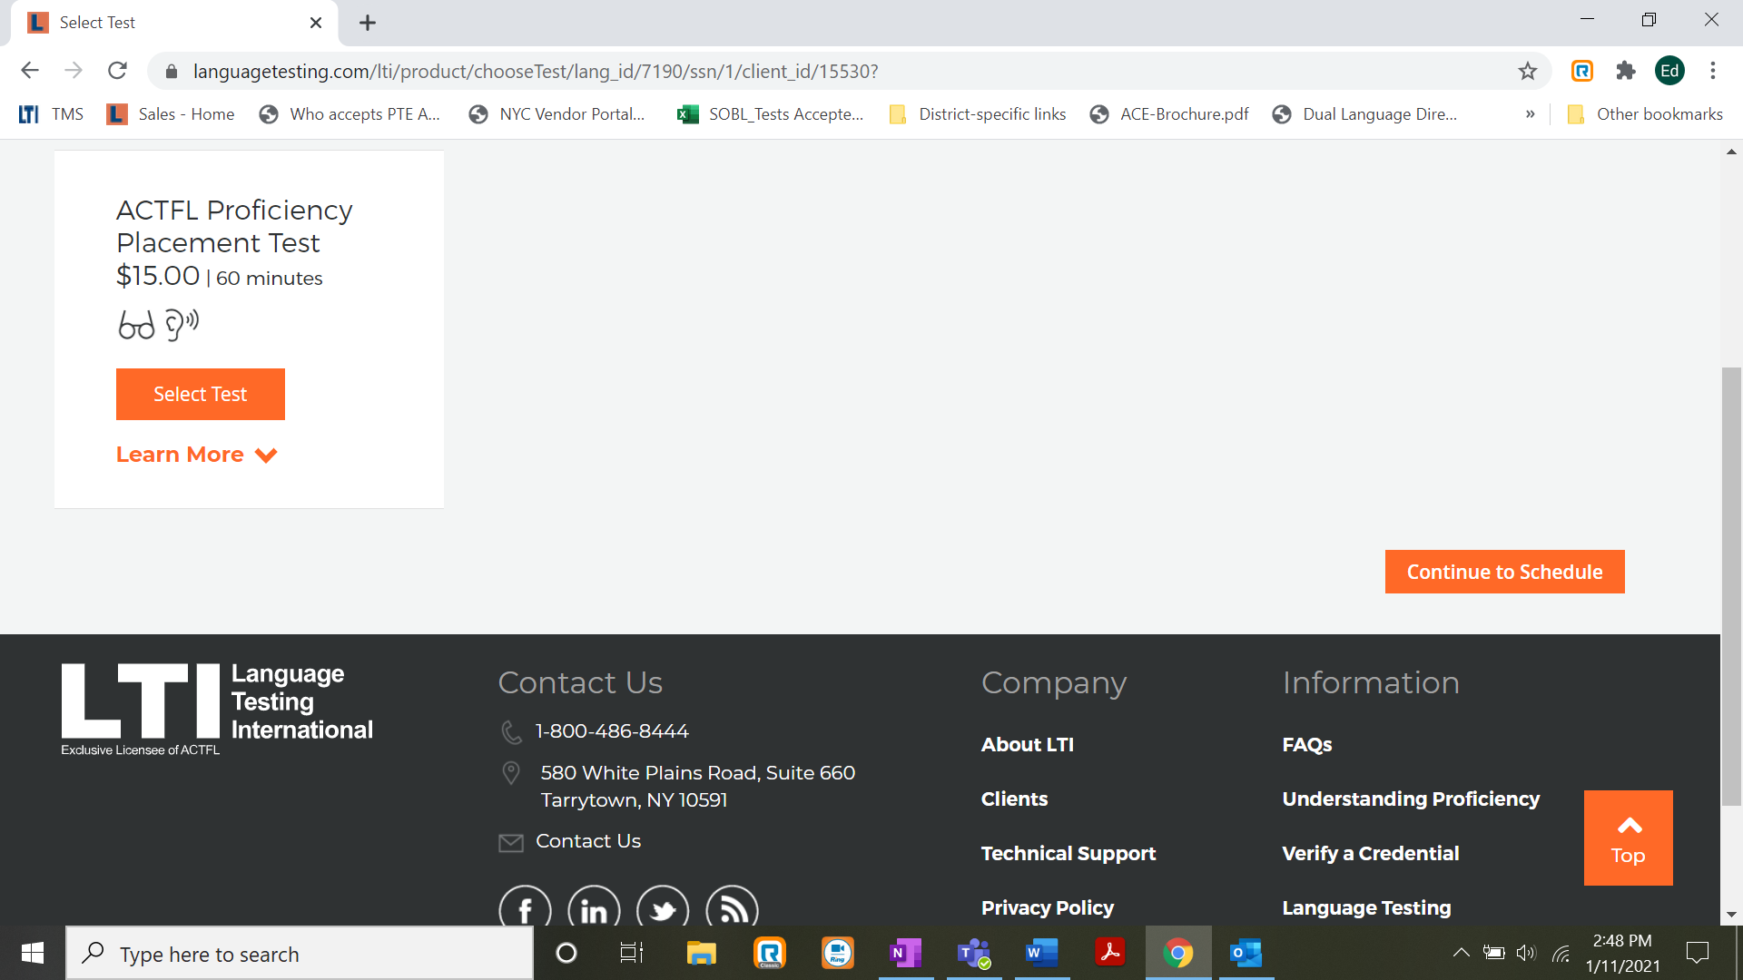

Select Spanish or French RPT with a time zone, and then Spanish or French LPT with a time zone, and select Next. (The time zone is arbitrary because this test, unlike other ACTFL tests, is not proctored).

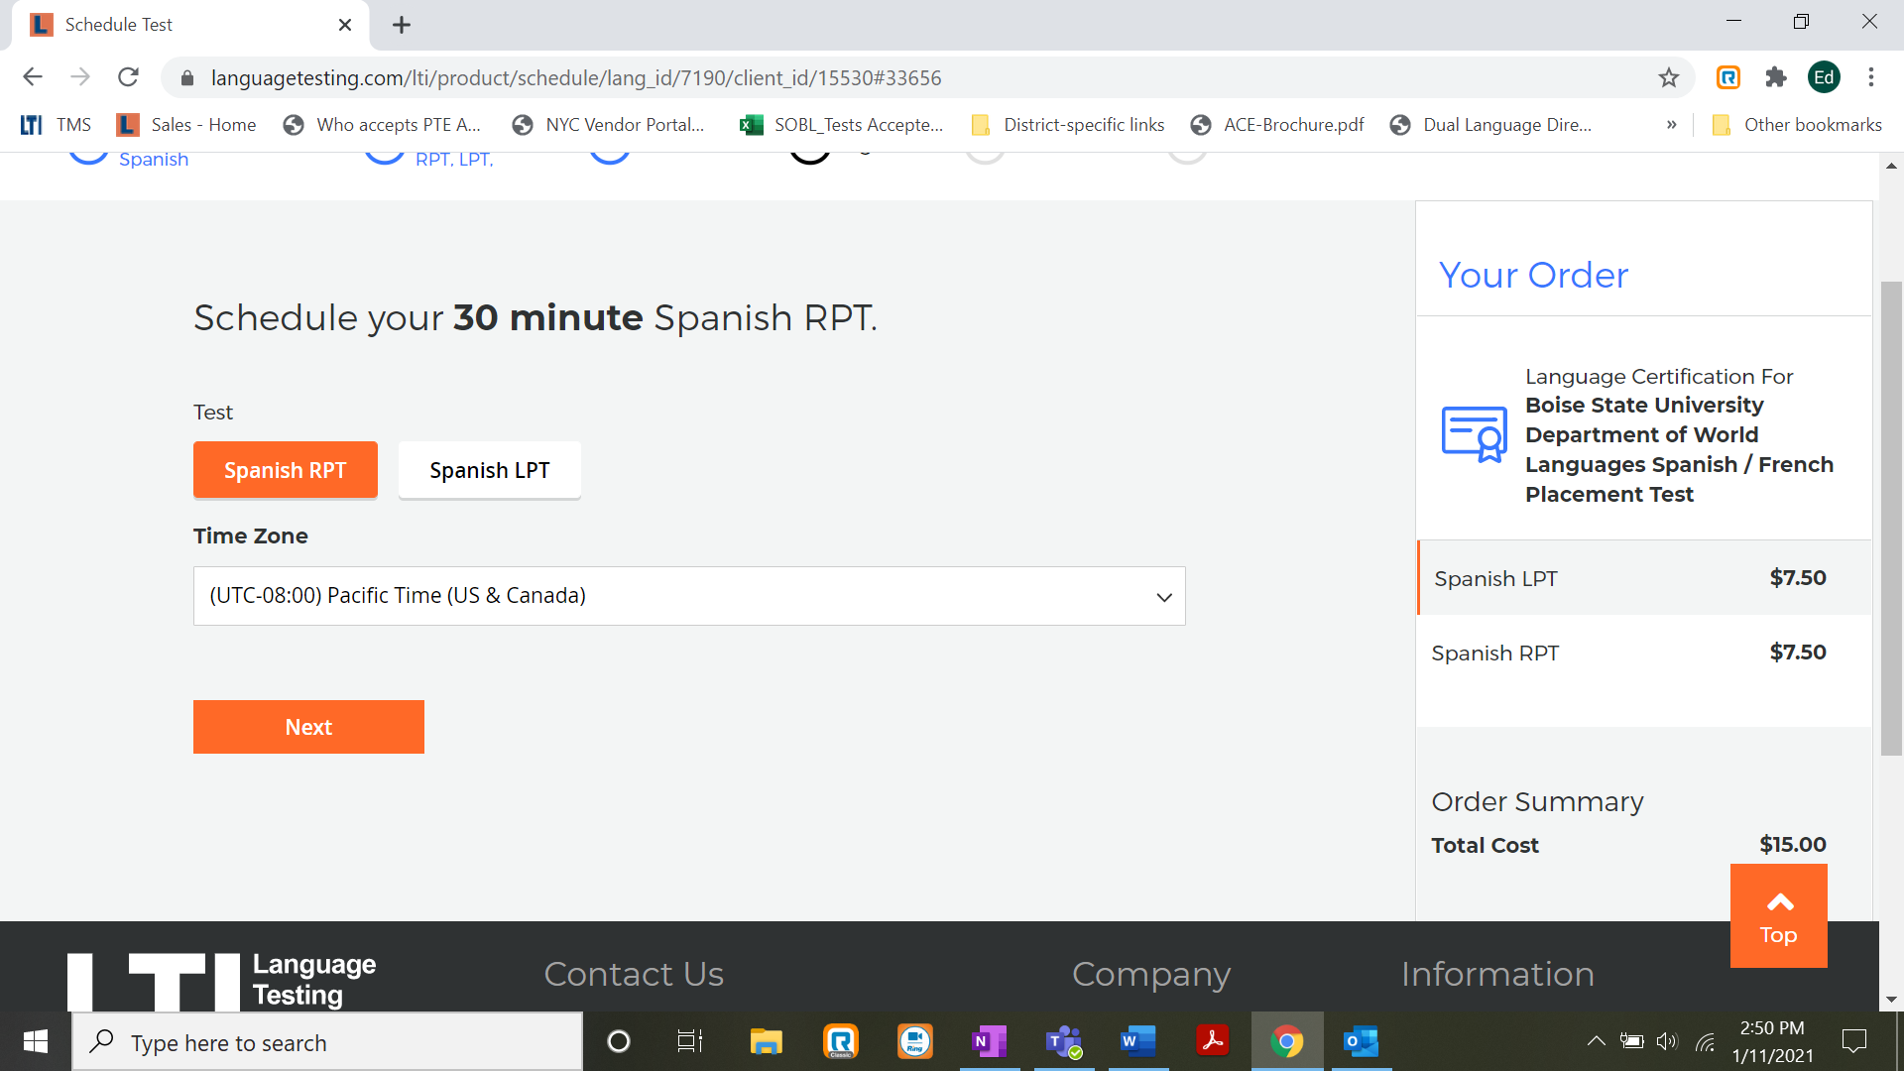

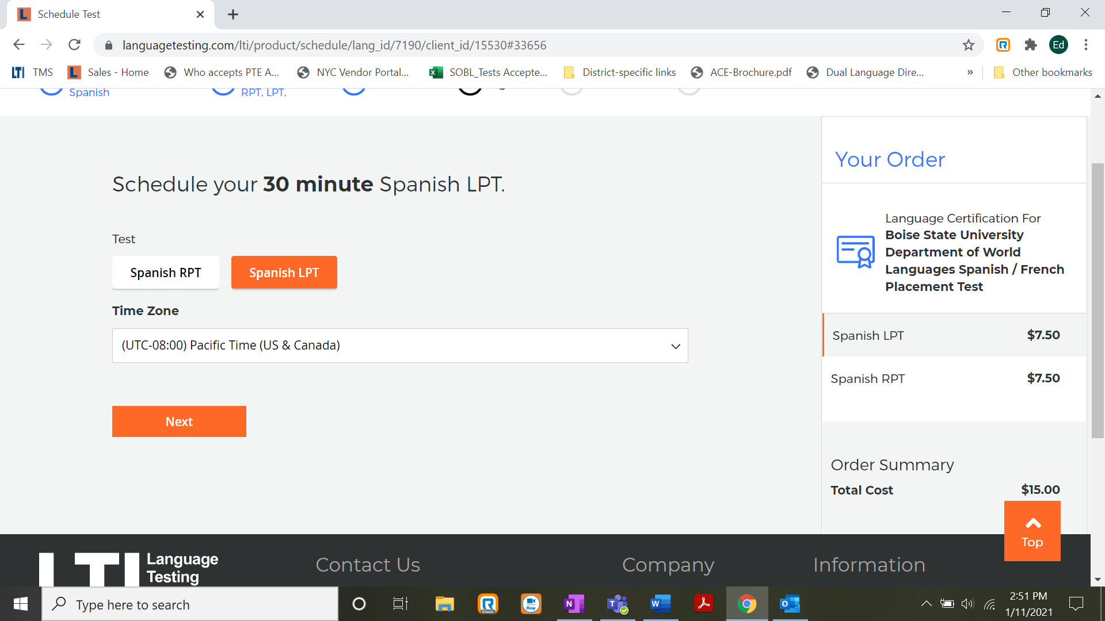

Then, open a Language Testing International account as you would with any other online service.

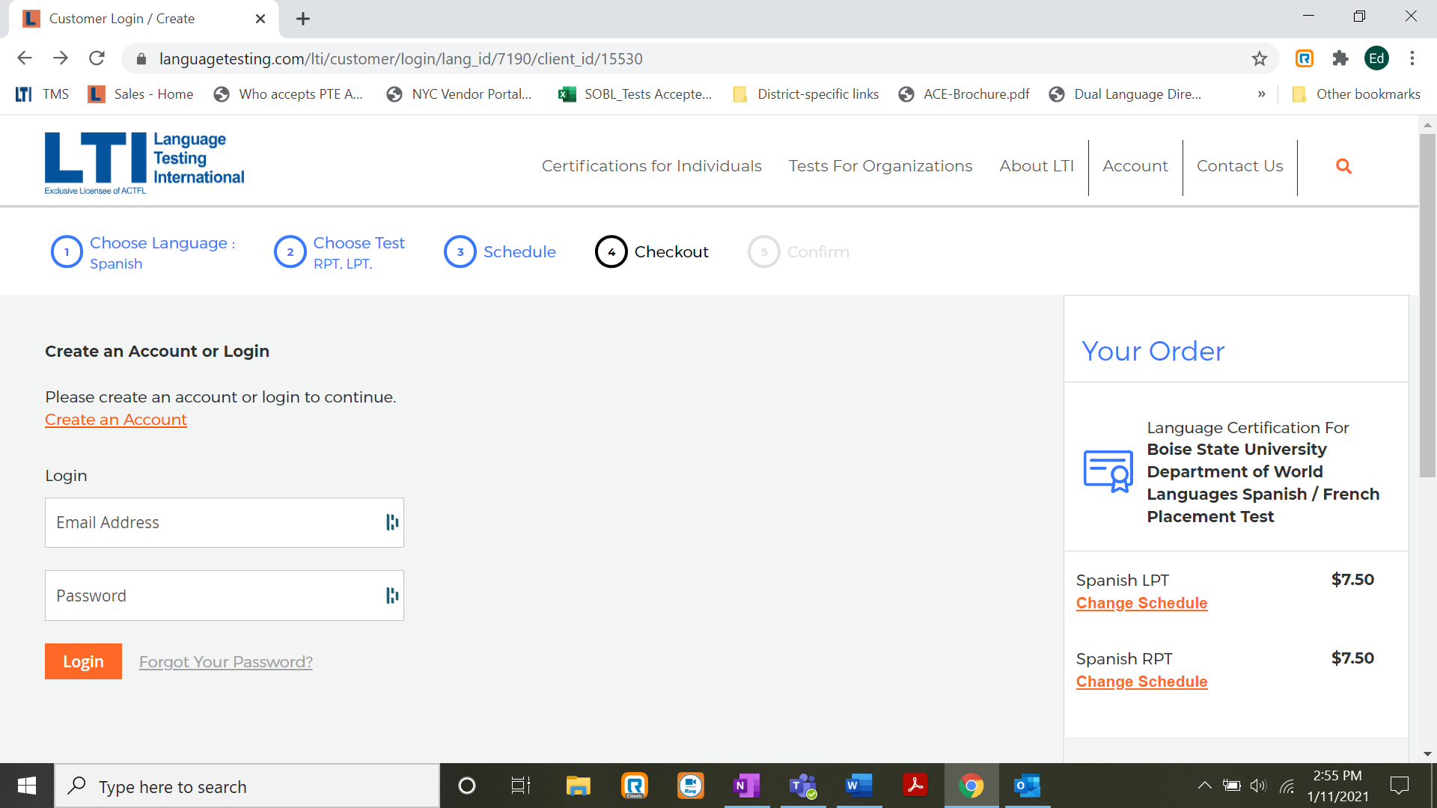

Then Return to the log in, purchase the test. You will then receive an email with login credentials.