Sample Daily Checklists for Powered Industrial Trucks

The following checklists are intended to assist in providing training on OSHA's powered industrial truck operator standards. They are not a substitute for any of the provisions of the Occupational Safety and Health Act of 1970 or for any standards issued by the U.S. Department of Labor's Occupational Safety and Health Administration (OSHA). OSHA wishes to acknowledge that this checklist and related graphics was developed in cooperation with the Industrial Truck Association as part of the OSHA-ITA Alliance.
The OSHA standard for powered industrial truck training [29 CFR 1910.178(l)] requires that an employer provide training to truck operators on a variety of topics. Among these topics are vehicle inspection and maintenance that the operator will be required to perform. The following checklists are being provided as part of OSHA's ongoing effort to assist employers and employees in ensuring that a safe and healthful workplace is provided. The lists serve as a guide only and may not be totally inclusive. Each type of powered industrial truck is unique and checklists pertinent to each type of vehicle should be modified accordingly. It is recommended that the manufacturer's instructions on vehicle maintenance and owner's and operator's responsibilities also be consulted. The OSHA standards for powered industrial trucks must be reviewed to ensure compliance.
There are two general types of powered industrial trucks: electric (battery) powered and internal combustion engine (gas/LPG/diesel) powered. Each of these general types has a variety of different configurations and attachments. Your workplace may have a variety of trucks that are being operated. ALL OPERATORS MUST BE TRAINED TO OPERATE ALL TYPE OF INDUSTRIAL TRUCKS THEY WILL BE OPERATING.
Daily, pre-shift inspection of powered industrial trucks is required by OSHA standards.
Depicted below are the major types of industrial trucks and some of the most common variations. The drawings of the trucks depicted below are intended to represent the typical configuration of trucks for each type. They do not include all available options, attachments or configurations.

Electric Motor Powered Industrial Trucks
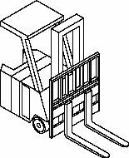  Standup End Control Rider | 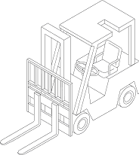  Sitdown Rider | 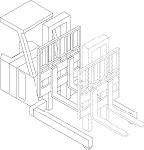  Narrow Aisle Reach
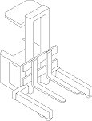  Narrow Aisle High Lift Straddle | 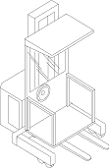  Narrow Aisle Order Picker | 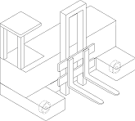  Narrow Aisle Sideloader Platform
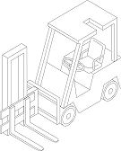  Narrow Aisle Sideloader High Lift Pallet | 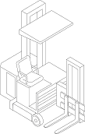  Narrow Aisle Turret | 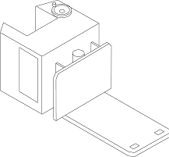  Narrow Aisle Low Lift Platform
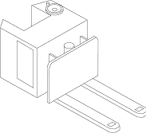  Stacker Pallet | 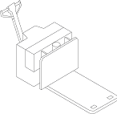  Walkie Platform Low Lift | 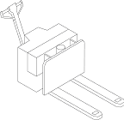  Walkie Pallet Low Lift
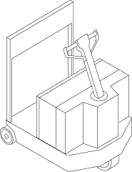  Tractor Walkie/Rider | 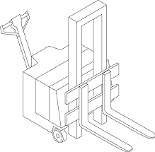  Walkie Pallet High Lift
Internal Combustion Engine Powered Industrial Trucks - Gas/LPG/Diesel
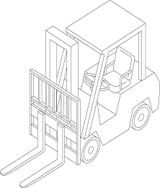  Counterbalanced Forklift Gas/LPG Cushion Tire | 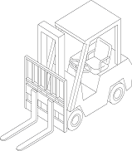  Counterbalanced Forklift Gas/LPG/Diesel Pneumatic Tire
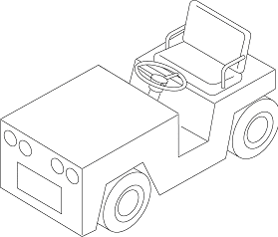  Tow Tractor Gas/LPG/Diesel | 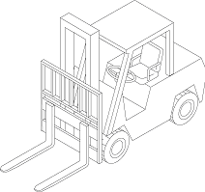  Rough Terrain Forklift Gas/LPG/Diesel Vertical Mast
Daily checklists for each type of industrial truck are available from the truck manufacturer. You may choose to use a checklist for each type of industrial truck in your workplace or compile one that can be used for any type of truck.
Refer to the owner's manual, specifications and manufacturer's recommendations to modify the checklist for trucks being operated in your workplace. Below are sample checklists for internal combustion and electric trucks. These lists can be modified to suit your workplace needs.

Operator's Daily Checklist - Internal Combustion Engine Industrial Truck - Gas/LPG/Diesel Truck
Record of Fuel Added
Date |  | Operator |  | Fuel
Truck# |  | Model# |  | Engine Oil
Department |  | Serial# |  | Radiator Coolant
Shift |  | Hour Meter |  | Hydraulic Oil
SAFETY AND OPERATIONAL CHECKS (PRIOR TO EACH SHIFT)
Have a qualified mechanic correct all problems.
Engine Off Checks | OK | Maintenance
Leaks – Fuel, Hydraulic Oil, Engine Oil or Radiator Coolant
Tires – Condition and Pressure
Forks, Top Clip Retaining Pin and Heel – Check Condition
Load Backrest – Securely Attached
Hydraulic Hoses, Mast Chains, Cables and Stops – Check Visually
Overhead Guard – Attached
Finger Guards – Attached
Propane Tank (LP Gas Truck) – Rust Corrosion, Damage
Safety Warnings – Attached (Refer to Parts Manual for Location)
Battery – Check Water/Electrolyte Level and Charge
All Engine Belts – Check Visually
Hydraulic Fluid Level – Check Level
Engine Oil Level – Dipstick
Transmission Fluid Level – Dipstick
Engine Air Cleaner – Squeeze Rubber Dirt Trap or Check the Restriction Alarm (if equipped)
Fuel Sedimentor (Diesel)
Radiator Coolant – Check Level
Operator's Manual – In Container
Nameplate – Attached and Information Matches Model, Serial Number and Attachments
Seat Belt – Functioning Smoothly
Hood Latch – Adjusted and Securely Fastened
Brake Fluid – Check Level
Engine On Checks – Unusual Noises Must Be Investigated Immediately | OK | Maintenance
Accelerator or Direction Control Pedal – Functioning Smoothly
Service Brake – Functioning Smoothly
Parking Brake – Functioning Smoothly
Steering Operation – Functioning Smoothly
Drive Control – Forward/Reverse – Functioning Smoothly
Tilt Control – Forward and Back – Functioning Smoothly
Hoist and Lowering Control – Functioning Smoothly
Attachment Control – Operation
Horn and Lights – Functioning
Cab (if equipped) – Heater, Defroster, Wipers – Functioning
Gauges: Ammeter, Engine Oil Pressure, Hour Meter, Fuel Level, Temperature, Instrument Monitors – Functioning
Operator's Daily Checklist - Electric Industrial Truck
Record of Fluid Added
Date |  | Operator |  | Battery Water
Truck# |  | Model# |  | Hydraulic Oil
Department |  | Serial#
Shift |  | Drive Hour Meter Reading |  | Hoist Hour Meter Reading
SAFETY AND OPERATIONAL CHECKS (PRIOR TO EACH SHIFT)
Have a qualified mechanic correct all problems.
Motor Off Checks | OK | Maintenance
Leaks – Hydraulic Oil, Battery
Tires – Condition and Pressure
Forks, Top Clip Retaining Pin and Heel -- Condition
Load Backrest Extension – Attached
Hydraulic Hoses, Mast Chains, Cables & Stops – Check Visually
Finger Guards – Attached
Overhead Guard – Attached
Safety Warnings – Attached (Refer to Parts Manual for Location)
Battery – Water/Electrolyte Level and Charge
Hydraulic Fluid Level – Dipstick
Transmission Fluid Level – Dipstick
Operator's Manual in Container
Capacity Plate Attached – Information Matches Model, Serial Number and Attachments
Battery Restraint System – Adjust and Fasten
Operator Protection
Sitdown Truck - Seat Belt – Functioning Smoothly
Man-up Truck – Fall protection/Restraining means - Functioning
Brake Fluid – Check level
Motor On Checks (Unusual Noises Must Be Investigated Immediately) | OK | Maintenance
Accelerator Linkage – Functioning Smoothly
Parking Brake – Functioning Smoothly
Service Brake – Functioning Smoothly
Steering Operation – Functioning Smoothly
Drive Control – Forward/Reverse – Functioning Smoothly
Tilt Control – Forward and Back – Functioning Smoothly
Hoist and Lowering Control – Functioning Smoothly
Attachment Control – Operation
Horn – Functioning
Lights & Alarms (where present) – Functioning
Hour Meter – Functioning
Battery Discharge Indicator – Functioning
Instrument Monitors – Functioning
ALL OPERATORS MUST BE TRAINED AND EVALUATED ON THE TYPES OF INDUSTRIAL TRUCKS AND ATTACHMENTS THEY WILL BE OPERATING.

