Honors 392
Date/Time/Location | September 11, 2018, 3pm, Albertsons Library 2nd Floor
Topic | Stitches of Resistance
Enduring Questions | What is information?
 | What is the relationship between identity and creating new information?
Learning Outcomes | Students will be able to:  - Understand that they are contributors to scholarship rather than only consumers of it (Scholarship as Conversation)  - Understand that first attempts do not always produce adequate results (Searching as Strategic Exploration)  - Seek appropriate help (including from peers) when needed (Research as Inquiry)
Facilitators | Elaine Watson, Amy Vecchione, Michael Mitchell
In Advance Needs | Have student makers set up and prep:  - Vinyl cutter and a laptop/computer at a table  - Sewn objects  - Sewing machines

Schedule
Time | Activity | Narrative/Main Points | Learning Objective
3pm-3:05pm | Introductions & Agenda |  | N/A
3:06-3:15pm | Discussion | Explore the question “Who is a maker and what is making?”  Touch on the following points:  It’s not that scary, it’s actually quite easy to do - and you will all do it. All are welcome!  What’s the most recent thing you made?  What is a makerspace?  Who gets to make things? | 1
3:16-3:24pm | Sharing | Share Examples of things that were sewn. Examples include Lilypad Arduino, Cape, Puppets, Knitting, Sewing Paper. Take care that these examples were not first attempts. | 2
3:25-3:40pm | Sewing Round Robin | Each group will go with one student assistant: 1, 2  Have each student learn how to thread the machine  Select a stitch  Sew a small pouch  Teach the next person | 1 and 3
3:41-3:47pm | Assessment | 1-minute paper – Respond to “what role do mistakes play in this class? In your education?”  Quick Debrief:  Mistakes are inevitable, we learn from them and grow  How else can you use the MakerLab in your classes? | 1, 2, 3
3:48-4pm | Wrap Up | Demos of vinyl cuter, button maker, and Lab Agenda

Hand Out Materials

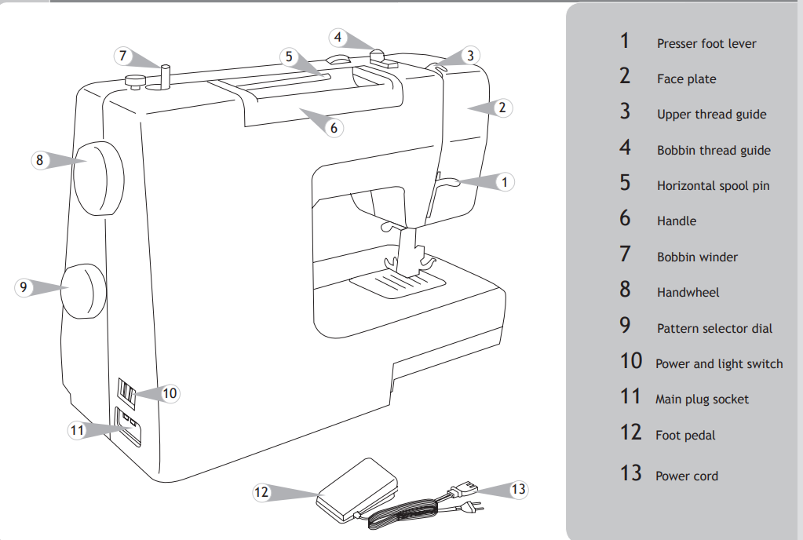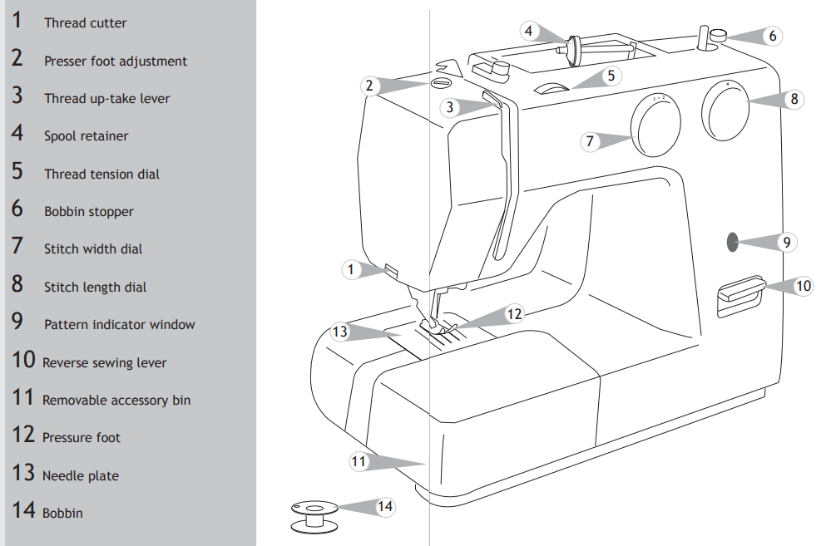
Steps to Follow to Sew
- Turn on the power switch
- Use the lever behind the foot to lift the foot
- Using the handwheel on the right side of the sewing machine, lift up the needle and pull the two threads to ensure they are not caught
- Place the fabric under the foot.
- Use one of the lines to the right of the foot, or the edge of the foot itself, as a guide for sewing a straight line
- Press on the foot pedal to start sewing
- Use the reverse lever to reinforce the stitches
- Turn the reverse lever off, and resume sewing down the side of the fabric.
- When you get to the end of the fabric, use the reverse lever to reinforce stitches.
- Use the handwheel on the right side of the sewing machine to raise the needle above the foot.
- Raise the foot.
- Pull the fabric away from the foot and cut the threads on the side.

