Click into Slate Reader

[Here is the link to the Slate portal to review the applications.](https://admissions.boisestate.edu/manage/)

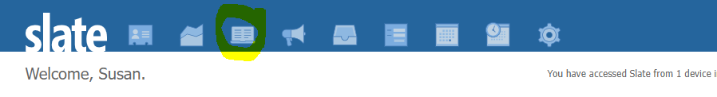

Click Browse

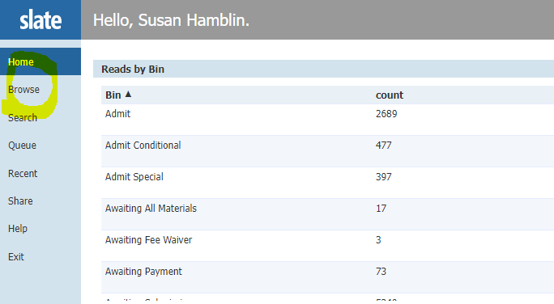

We only look in Bins “Program Processing and Awaiting Transcripts.”

If an international student does not have all Official Transcripts submitted, they are not moved into Program Processing, even if all other requirements are met and unofficial transcripts submitted.

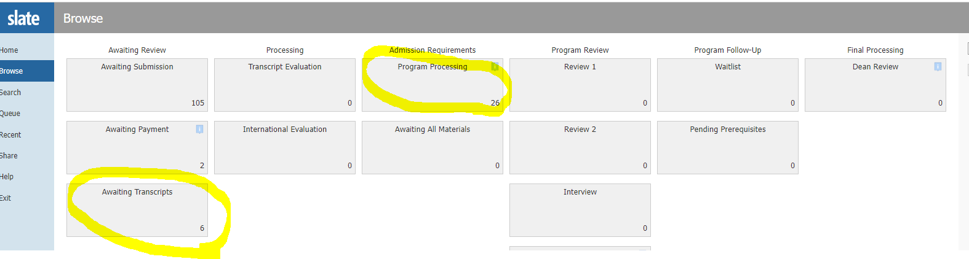

To view the application, click on the file icon on the far right. (There are older applications in the portal but Grad College does not remove them until the next AY year has closed).

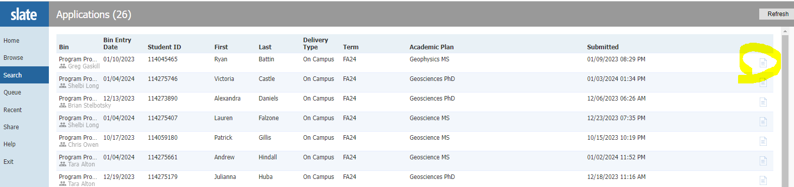

Click on Dashboard to review materials. There are a few other options to get into the application but this is the easiest.

