Instructions for making shrink-teflon microcolumns
for U-Pb ion chromatography

Materials:
3/8” 4:1 shrink teflon (PTFE) — Zeus Plastics http://www.zeusinc.com/extrusionservices/products/heatshrinkabletubing/ptfehs41heatshrink.aspx
1/16” porous polyethylene sheet (hydrophilic) — Scientific Commodities Inc. #BB2062-70L
http://www.scicominc.com/index.php/products/porous-sheets
1/16” teflon (PTFE) sheet — McMaster-Carr
http://www.mcmaster.com/#plastics/=awm9fm
1/4" o.d. teflon (PTFE) rod — McMaster-Carr
http://www.mcmaster.com/#rod-stock-%28made-with-teflon-ptfe%29/=awm9wc
3/8" o.d. teflon (PTFE) rod — McMaster-Carr
http://www.mcmaster.com/#rod-stock-%28made-with-teflon-ptfe%29/=awm9wc

Tools:
Multi-diameter hole punching tool — McMaster-Carr #3426A1
http://www.mcmaster.com/#hole-forming-punches/=awmb2n
1/4” i.d. (#9) punch (for punching stem hole) — McMaster-Carr #3424A19
http://www.mcmaster.com/#hole-forming-punches/=awmb2n
Form, from 3/8” o.d. teflon (PTFE) rod, end rounded, with 1/8" i.d. hole bored through center
http://www.mcmaster.com/#rod-stock-%28made-with-teflon-ptfe%29/=awm9wc

Savillex PFA vial with 6M HCl
Laboratory swabs (Q-tips, wood or plastic)
Scissors
Razor blade
Straight-edge and/or paper cutter
Heat gun
Liquid nitrogen in a small open dewar
200 µl variable volume pipettor
MQH2O

Instructions:
- Prepare the column holder from the 1/16” teflon sheet by cutting into 5/8” x 3-1/2” rectangles (easily done on a paper cutter), beveling the corners, and then punching a 1/4" dia. hole 3/8” from one end, and a 3/32” dia. hole 1-1/4” from other end. Clean these with soap and water, then soak in a bath of 6M HCl, rinse with MQH2O and dry.
- Prepare frits by punching out from the 1/16” porous polyethylene sheet with a 5/64” punch. Clean these in 6M HCl in a small PFA vial on a hotplate overnight, then sonication in clean 6M HCl, then MQH2O, and dry.
- Fabricate a form for shrinking the column from the 3/8” dia. rod, by rounding one end and boring a hole through the center (see above).
- Cut the shrink teflon into 1-1/4” lengths with a scissors, and slide the (reservoir) end of the shrink teflon 1/2" onto the form (should be snug). Place the shrink teflon (including the end of the form) into the stream of the heat gun, and shrink the teflon evenly by rotating the form under the heat, watching for the teflon to turn transparent. Once the teflon has shrunk immediately plunge the end of the form into liquid nitrogen to quench.
- Slide the shrunken (column) end through the 3/32” dia. hole in the column holder. Using the end of the laboratory swab, gently flare the column end, place a frit on the end of the swab, and push it smoothly and evenly into the end of the column. Make sure to keep the frit perpendicular to the column walls as you push it in.
- Deliver the required volume (e.g. 50 µl) of MQH2O into the column, starting from the frit and filling the column upward. Immediately (before the MQH2O can pass into the frit) use the swab to push the frit upward into the column until the volume of MQH2O rises to the top of the column. Use a razor blade to cut off the end of the column ~1/32” below the frit, at a slight bevel.
- The assembled column+holder can be stored in a plastic tub in 6M HCl between uses; for cleaning prior to use the columns can be filled with resin and placed on a stand consisting of a 1/4" dia. teflon rod mounted upright (e.g. stuck into 1/4" hole in a ~3” teflon disk), and placed in the lid of an appropriately sized inverted plasticware container (see photo).
- Sixteen columns can be set up for a single batch of chemistry using a lazy susan assembly (see separate plans).

 | 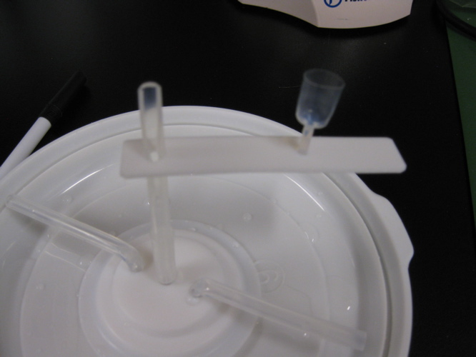
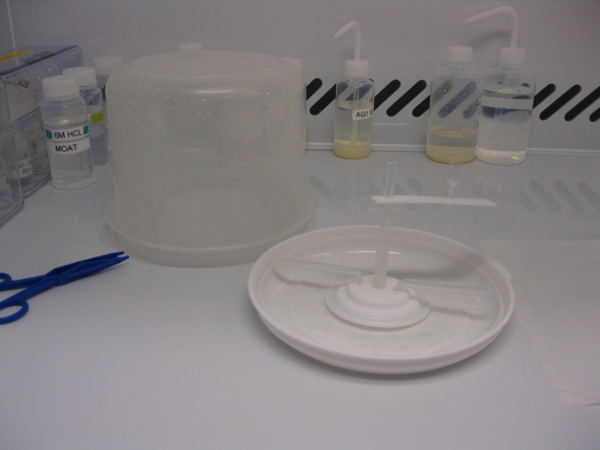 | 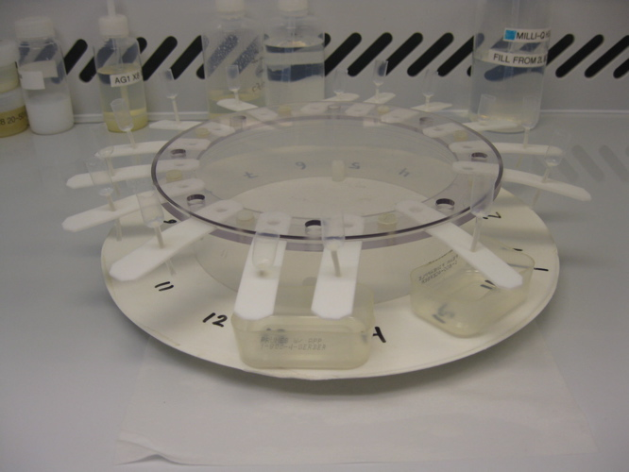
Instructions for making lazy susan for shrink-teflon microcolumns
for U-Pb ion chromatography

Materials:
Spin Tray, 13" diam. x 1-1/2" h — Container Store #564010
http://www.containerstore.com/shop?productId=10007006&N=&Ntt=spin+tray
3 qt. Round Keeper 2.8 ltr., 7-1/4" diam. x 5-1/4" h — Container Store #10029313
http://www.containerstore.com/shop?productId=10014891&N=&Ntt=3+qt.+round+keeper
1/8” acrylic sheet — McMaster-Carr
http://www.mcmaster.com/#plastics/=awm9fm
12 - #8-32 x 1” plastic (nylon or other) machine screws (binder head) — McMaster-Carr
http://www.mcmaster.com/#machine-screws/=ax383s
12 - #8 x 1/16” thick plastic flat washers (nylon or other) — McMaster-Carr
http://www.mcmaster.com/#washers/=ax39qm
12 - #8-32 x 1” plastic machine screw nuts (nylon or other) — McMaster-Carr
http://www.mcmaster.com/#plastic-hex-nuts/=ax3aih
4 - #8 x 3/8” dia. x 1/2” h plastic spacer (nylon or other) — McMaster-Carr
http://www.mcmaster.com/#spacers-and-standoffs/=ax4b22

Tools:

saw
drill
3/8” drill bit
razor blade
wire cutter
Sharpie

Instructions:
- The lip of the spin tray should first be trimmed off with a saw, and then four 3/16” dia. holes drilled through the tray, along a radius 3-3/16” from the center of the tray.
- Push four plastic #8-32 machine screws through the 1/2” spacers and then through the top of the tray, and fasten with washers and nuts. Closely trim off the end of the machine screw with a wire cutter. The machine screw heads with spacers serve as guide posts for the circular band made from the round keeper.
- Cut the bottom off of the round keeper, 2” from the top, preserving the neatly trimmed upper band. The bottom can be discarded, or used as a wash tray. The circular band can now be placed right-side up onto the spin tray, friction fit around the machine screw posts.
- Have a machine shop fabricate the disk and ring pieces illustrated on the next page from 1/8” acrylic sheet. Align the ring above the disk, with the beveled edges facing each other, and insert a plastic #8-32 machine screw from the bottom through the disk, add a washer between the disk and the ring, and fasten the ring to the disk with a nut. Repeat with all 8 holes, and closely trim off the end of the machine screw with a wire cutter. Place the coupled disk and ring onto the circular band (ring up), friction fit around the machine screw heads.
- Label 16 spaces around the circumference of the spin tray with the Sharpie marker; the three pieces of the tray can be easily disassembled and wiped clean between uses.

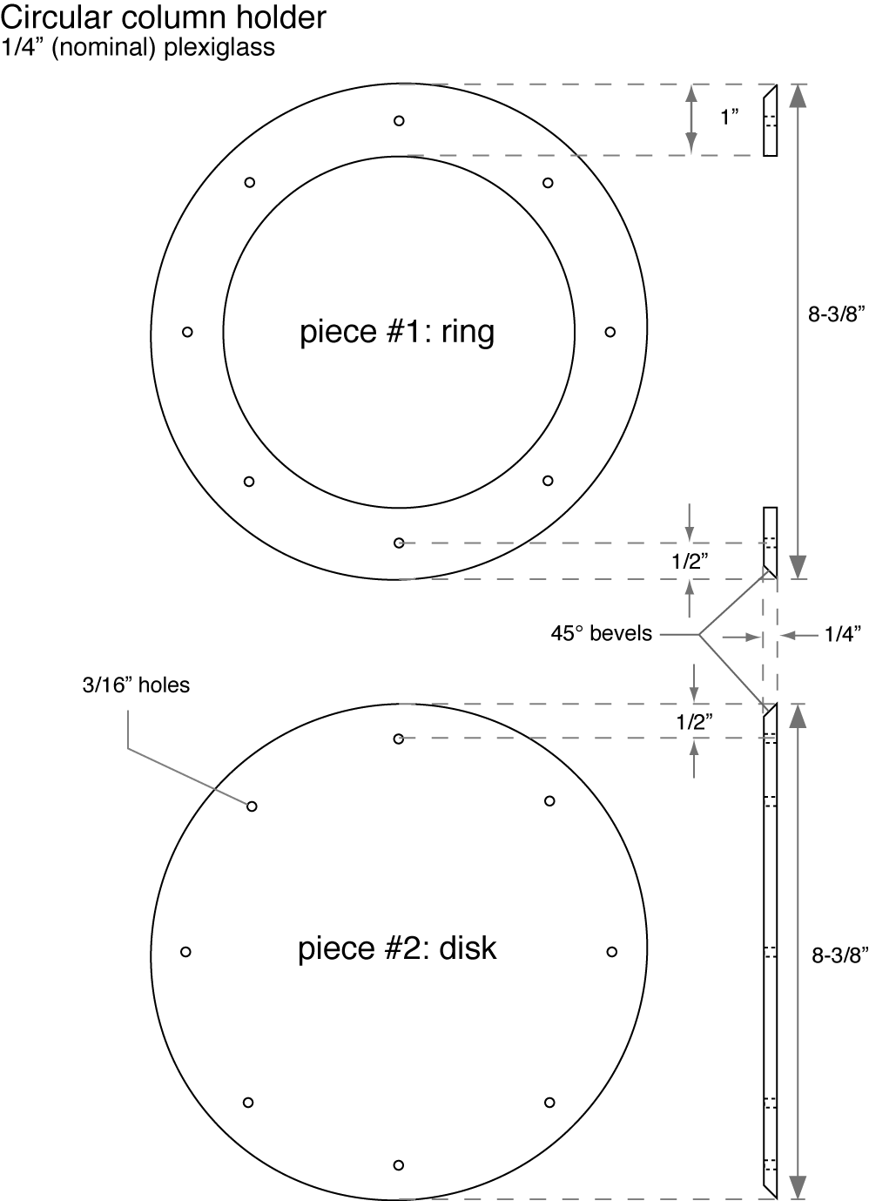

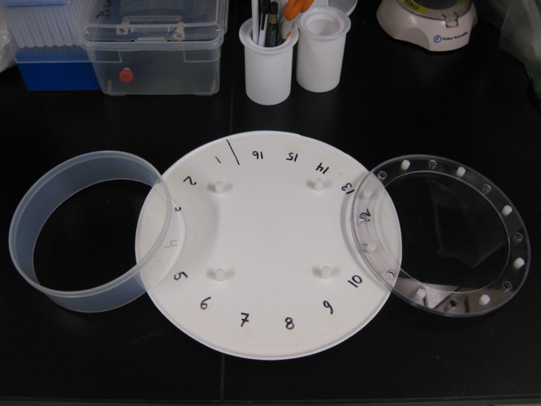 | 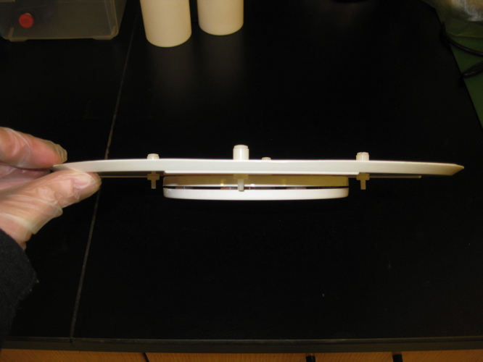
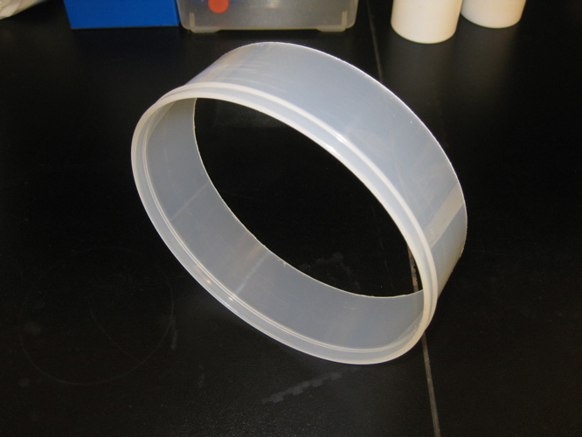 | 