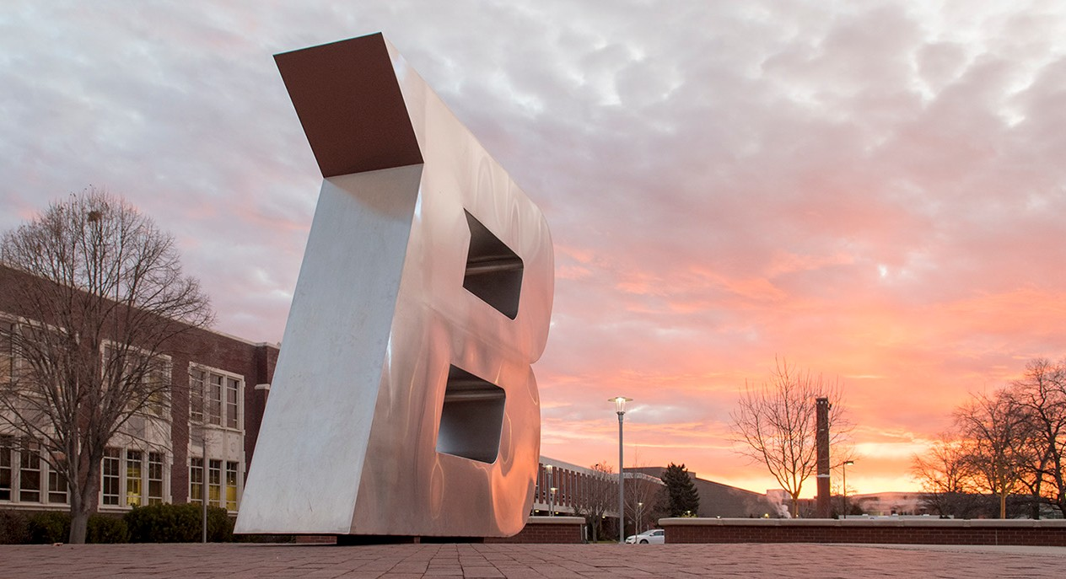

OPT-IN TO BRONCO ALERT

RECEIVE EMERGENCY NOTIFICATIONS IMPACTING CAMPUS

BRONCO ALERT IS BOISE STATE UNIVERSITY’S

**PLEASE NOTE**

OFFICIAL EMERGENCY NOTIFICATION SYSTEM

It allows you to quickly receive emergency notification about

BroncoAlerts are not

used for any type of marketing or non- emergency campus announcements.

Once enrolled, a user will remain in the BroncoAlert system until the end of the summer semester.

threats and hazards impacting the Boise State campus along with

important crime alerts via email, text messages, and/or recorded

voice messages. Signing up for BroncoAlert is the quickest way to

receive emergency alerts and be in the know so you can respond

quickly and safely in an emergency situation on campus.

All current Boise State faculty, staff and students are automatically

enrolled in BroncoAlert each semester through their Boise State

email account. However, camp employees, volunteers, and parents

of campers who are not affiliated with the University may also

enroll in BroncoAlert. To enroll in the BroncoAlert emergency

notification system, please visit https://getrave.com/login/boisestate.

Click on “Register” and complete the online registration form.