System Information
Machine: Spin-Rinse-Dryer (SRD)
Manufacturer: Semitool
Model #: ST-460

Operating and Maintenance Procedures

Getting Started
- Turn on DI water supply (Figure 1). You should have about 2.5GPM during machine operation.
- Turn on Nitrogen gas supply (Figure 2). This is set to ~35psi and should not be changed at any time.

DI Water Nitrogen
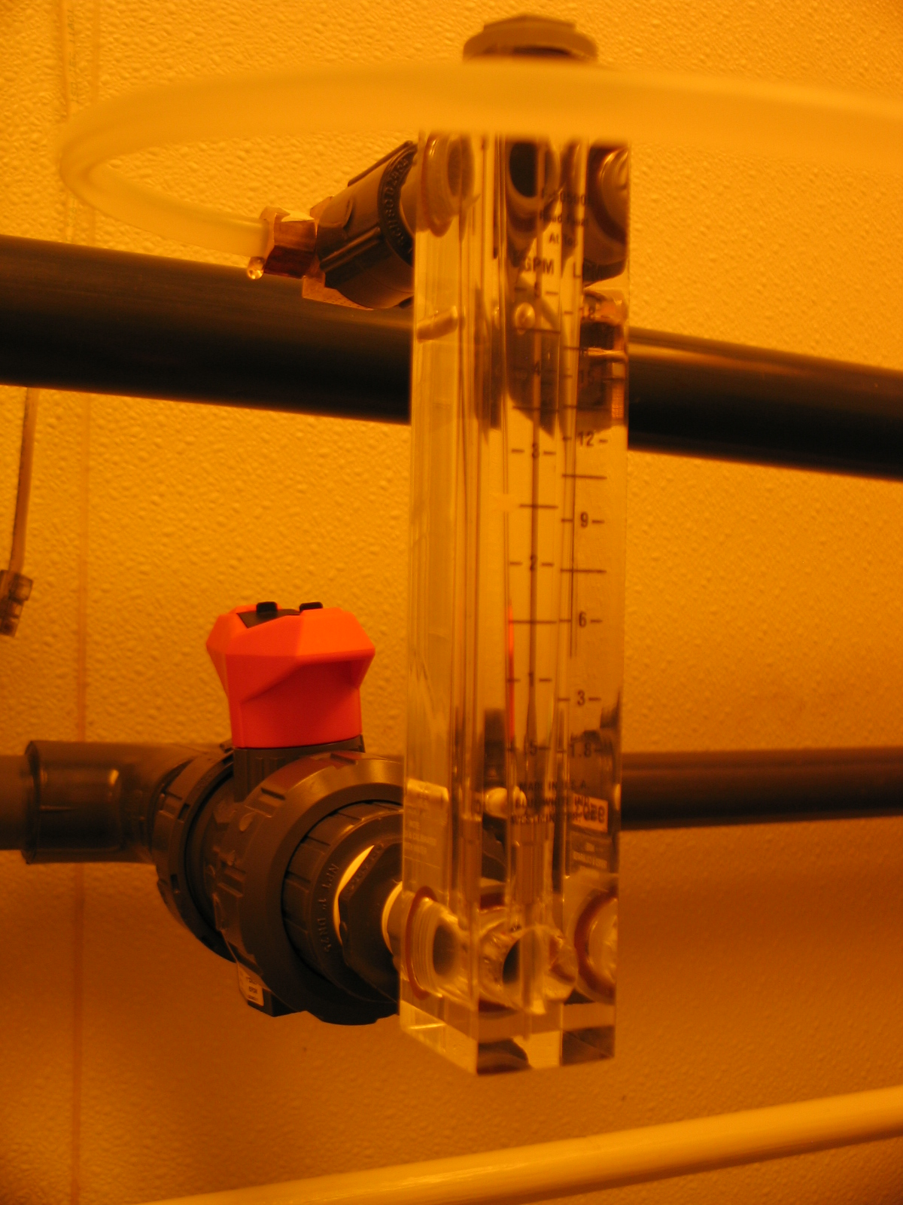
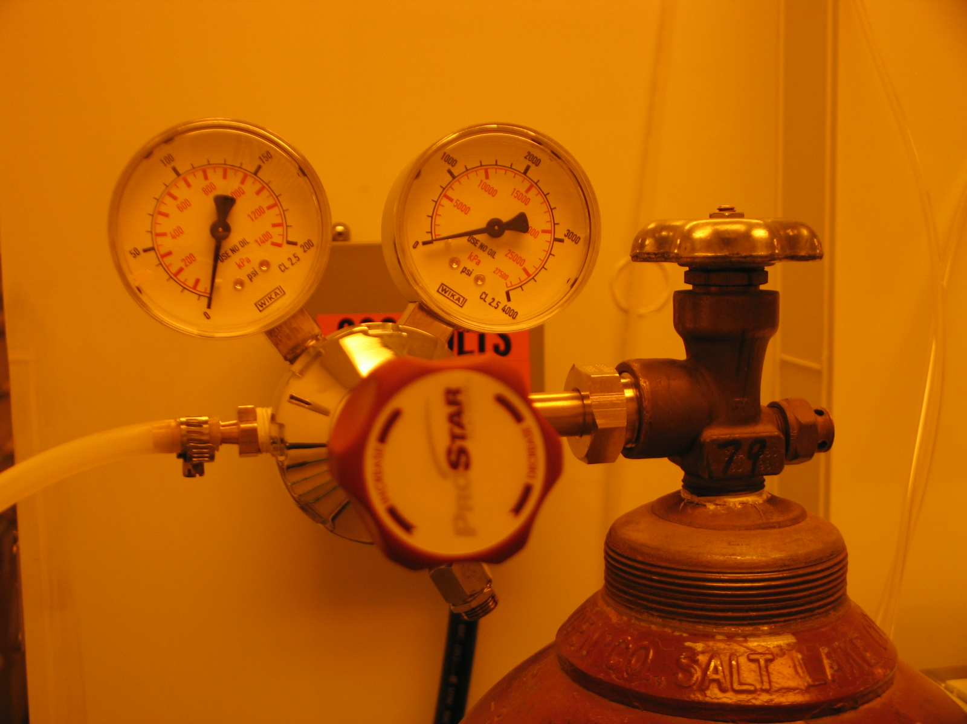

F1:2.5 GPM F2:30-35psi

Loading Wafer Cassette
- Load wafers into designated flouroware cassette. The cassettes are designed to hold as many as 25 wafers at a time. If you are processing less than 25 wafers, please be sure to space the wafers every other slot in the cassette.
- Load the cassette into the rotor with the “H-handle” loaded closest to the back of the machine. Or slot #1 should be on the inside of the cassette furthest away from you (Figure 3).

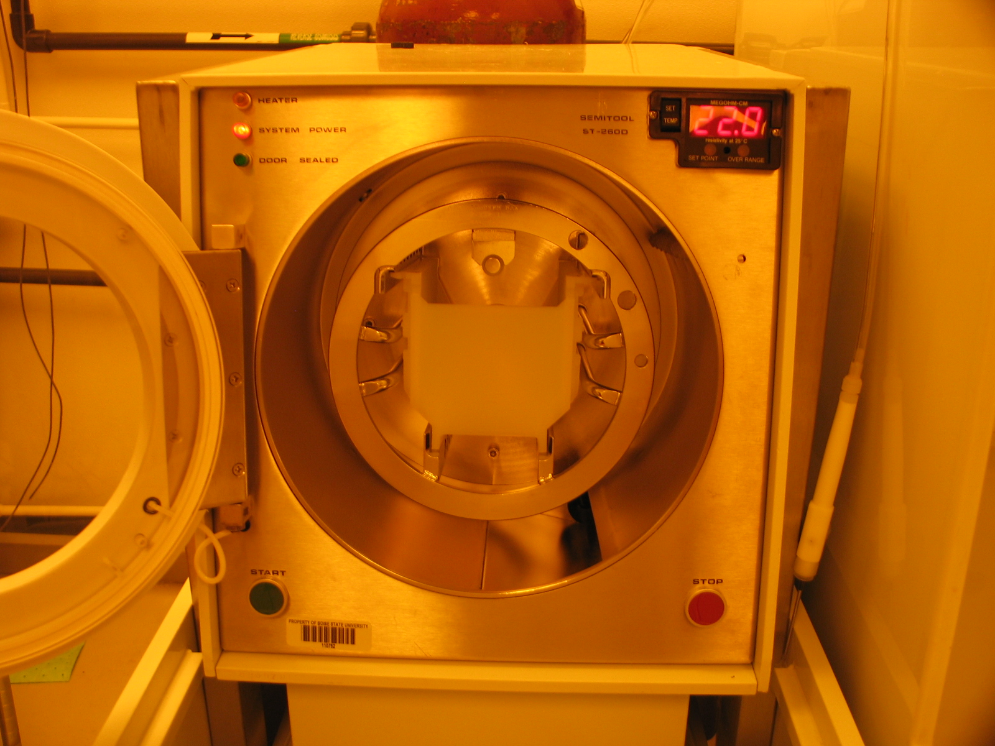

F3: Orientation of Wafer Cassette as you are
looking at the front of the machine.

SRD Operation
- Close front door and press the start button located at the bottom left.
- The SRD is preprogrammed to rinse for 60 seconds and dry for 90 seconds. If you would like to change the settings, please see the IML manager.
- Once the tool has completed its cycle the rotor will spin down and rotate to its original loading position.
- You can then unload your cassette.

SRD Shutdown
- Turn off DI water supply,
- Turn off Nitrogen gas.
- Clean up your space.

Note: The SRD dry cycle rotates at 2500rpm. Please report any unusual noise or vibrations coming from the machine during its rinse cycle. If the noise does not sound good it probably isn’t good for the machine, you can abort the cycle at any time by pressing the STOP button located on the bottom right.

