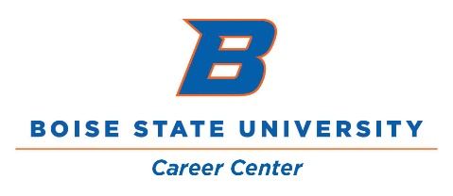

Career and Life Planning – Pre/Post Assessment Report
Period: Academic Years 14/15 to 17/18
Career and Life Planning is an online, letter-graded, 1-semester course available to any Idaho high school student through the Idaho Digital Learning Academy. Students may choose to also register for dual credit through Boise State and receive 2 college credits for completing the course.

Enrollment:

Total Students Served: 622  - 14/15: 49 students and 28 high schools served  - 15/16: 91 students and 43 high schools served  - 16/17: 228 students and 74 high schools served  - 17/18: 254 students and 75 high schools served |  |  | Year in High School:  - Freshman/Sophomore: 182  - Junior: 240  - Senior: 206
High Schools Served:
- Aberdeen  - American Falls  - Atlas  - Bingham Academy  - Blackfoot  - Boise  - Bonners Ferry  - Buhl  - Burley  - Butte County  - Camas County  - Canyon Ridge  - Capital  - Carey  - Cascade  - Castelford  - Centennial  - Central Academy  - Century  - Challis  - Clark County  - Clearwater Valley  - Coeur d’Alene  - Council  - Culdesac  - Deary  - Declo  - Dietrich  - Eagle  - Emmett | - Filer  - Fruitland  - Garden Valley  - Glenns Ferry  - Gooding  - Grangeville  - Greenleaf Friends Academy  - Hansen  - Highland Craigmont  - Highland Pocatello  - Homedale  - Horseshoe Bend  - Idaho Digital Learning Academy  - Idaho Distance Education Academy  - Idaho Technical Career Academy  - Idaho Virtual Academy  - INSPIRE Idaho Connections Academy  - iSucceed Virtual High School  - Jerome  - Kellogg  - Kendrick  - Lapwai | - Lewiston  - Lighthouse Christian  - Mackay  - Madison  - Malad  - Marsh Valley  - Marsing  - Melba  - Meridian  - Middleton  - Midvale  - Minico  - Mountain Home  - Mountain View  - Nampa  - Nampa Christian  - New Plymouth  - North Freemont  - North Gem  - North Idaho Christian  - North Star Charter  - North Valley Academy  - Notus  - Oakley  - Orofino  - Parma  - Payette  - Potlatch  - Preston |  | - Raft River  - Renaissance  - Rigby  - Ririe  - Rockland  - Rocky Mountain  - Sage International  - Salmon  - Sandpoint  - Skyline  - Skyview  - Snake River  - Soda Springs  - South Fremont  - St. Maries  - Taylor’s Crossing  - Timberline  - Thomas Jefferson  - Troy  - Twin Falls  - Valley  - Vallivue  - Vision Charter School  - Wallace  - Weiser  - Wendell  - West Side  - Wood River

Map of High Schools Served
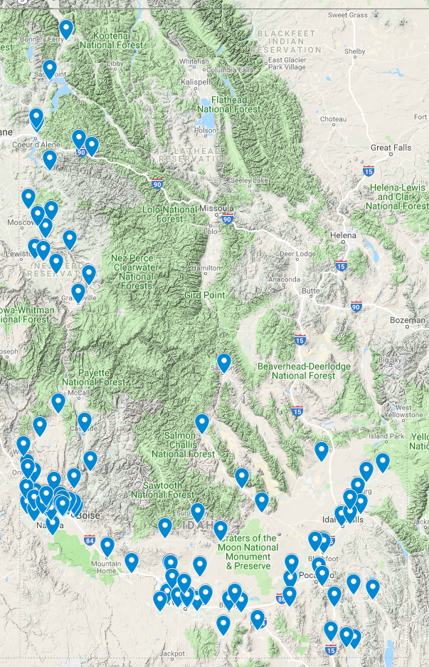
College Plans:

Have you decided what college you are going to?

If you haven’t decided, why? (Post-Assessment)
Common Themes:
- Too early in high school to make a decision and/or haven’t looked at colleges enough yet
- Highly concerned about cost - need to see what scholarships/financial aid are received and research total cost to determine which college is most affordable
- Need to participate in campus visits or additional campus visits
- Need to make decision about what program of study or career path to pursue

Major Plans:
Have you decided what your major or program of study is going to be?

Which best describes where you are in the career decision-making process?

What information do you still need and/or what do you need to do to make a decision? (Post-Assessment)
Common Themes:
- Opportunities to try things out/ gain hands-on experience outside the classroom before committing
- Do more informational interviews
- More in-depth research to assess details of the career
- Learn more about specific options within a field of interest
- Need to take time to learn more about myself, more time to think/weigh options
- Need to take related classes and see how I feel about them
- Cost of college – what I can afford and where will impact what career I can pursue
Learning Objectives:

 | 1: To increase your level of self-knowledge and understanding of what you want in a career.
Questions:

- How well-defined is your work identity?
 | Pre: 6.82 | Post: 7.86 | Gain: 1.04
 | - How aware are you of your career-related interests?
 | Pre: 6.90 | Post: 8.39 | Gain: 1.49
 | - How aware are you of your career-related skills and abilities?
 | Pre: 6.68 | Post: 8.33 | Gain: 1.65
 | - How aware are you of your work values?
 | Pre: 7.45 | Post: 8.70 | Gain: 1.25
 | - How aware are you of how your personality characteristics match up to characteristics of work environments?
 | Pre: 7.08 | Post: 8.54 | Gain: 1.46

 | 2: To explore and research available careers and identify appropriate career options.
Questions:

- How much do you know about how to find out what careers exist?
 | Pre: 6.10 | Post: 8.37 | Gain: 2.27
 | - How much do you know about how to go about finding careers that might fit you?
 | Pre: 5.72 | Post: 8.31 | Gain: 2.59
 | - How much do you know about where and how to obtain information about different careers?
 | Pre: 5.83 | Post: 8.41 | Gain: 2.58
 | - How confident are you in your present ability to identify careers that fit your interests, abilities, values, and personality?
 | Pre: 6.44 | Post: 8.41 | Gain: 1.97
 | - How confident are you in your present ability to select a career path that best fits you?
 | Pre: 6.20 | Post: 8.31 | Gain: 2.11

 | 3: To utilize knowledge of self and desired career paths to identify appropriate options for postsecondary education.
Questions:

- To what extent have you used your career goals to identify the most appropriate options for postsecondary education?
 | Pre: 5.93 | Post: 8.12 | Gain: 2.19
 | - How aware are you of what type of postsecondary school you will need to attend and what type of degree or certificate you will need for your career?
 | Pre: 5.83 | Post: 8.59 | Gain: 2.76
 | - How confident are you in your present ability to select the postsecondary school and degree or certificate that will best prepare you for your chosen career path?
 | Pre: 5.80 | Post: 8.33 | Gain: 2.53

 | 4: To learn how to plan and prepare to successfully obtain a desired career.
Questions:

- How much do you know about what kinds of opportunities to seek out while in college to make yourself competitive for your desired career?
 | Pre: 5.23 | Post: 8.21 | Gain: 2.98
 | - How confident are you in your ability to create an effective career preparation action plan?
 | Pre: 5.68 | Post: 8.23 | Gain: 2.55
 | - How much do you know about current hiring practices and how to conduct an effective job search?
 | Pre: 5.15 | Post: 8.09 | Gain: 2.94
 | - How much do you know about how to create and promote your personal brand?
 | Pre: 4.53 | Post: 8.03 | Gain: 3.50
 | - How much do you know about how to build a professional network before entering your career?
 | Pre: 4.17 | Post: 8.08 | Gain: 3.91
 | - How much do you know about how to write effective resumes and cover letters?
 | Pre: 5.29 | Post: 8.31 | Gain: 3.02
 | - How much do you know about how to interview successfully?
 | Pre: 5.55 | Post: 8.43 | Gain: 2.88

Course Feedback:
Selected Responses:
- This course has helped me create a clear path towards achieving my goals. The information presented about the career planning process, education options, my personality, my skills, my work values, certain careers, the job market, the job search process, and other particulars have given me a solid foundation in this area. Even if I haven't committed to a single path, this foundation has given me the knowledge and confidence to continue my research, decision making, and planning beyond this course until I decide what is right for me.
- I am ready for my future and can see an ending goal that I may not have seen if it weren’t for this class.
- The most valuable thing I'm taking away from this course is learning the action plan that must be taken in order to be successful in higher education and a career. Learning about how to research colleges, degrees, as well as career fields, was extremely helpful. I now have resources that I will depend on when looking for this information.
- This class helped me know about the different college options available to me. This helped me make the final decision about where I want to go to school.
- It opened my eyes to all the options that are actually out there when it comes to schooling and career choices. I was able to find more careers that interested me than the kind of jobs I have heard about growing up.
- It showed me all the different types of post secondary schools and differentiated them. It also educated me on how to make yourself a desirable employee in the eyes of an employer.
- The most valuable thing I learned was how to really look into things and thoroughly research before making a decision. This is something I personally need to work harder on, and it really helped me decide what my post graduation plan will be.
- This course allowed me to know what type of person I am. It was valuable because I am able to see what type of careers are right for me and what a career needs to include in order for me to be happy.
- The most valuable thing I learned would have to be just finding myself. I learned so many different things about myself that I wouldn't have found out otherwise.
- It pushed me to search for options and reflect on what I want because I haven't thought much on it before.
- I loved doing the interview assignment. I got to go out and see people who are working in my general desired field and it was very helpful to put it into perspective and help me to stop thinking of my future just on paper.
- We got some hands on experience with putting ourselves out there in the real world. For example, we made a legitimate LinkedIn account and also had to make a resume. That's the type of stuff we'll actually be doing in real life.
- It was hands on and encouraged me to go out and to take some personal initiative.
- It has forced me to truly question what is important for me in a job and where I wish to see myself when I am older. This has made me change my original plan of what I wanted to do.
- When I first started this course I had no idea what I was doing with my life and I was terrified. Now I feel more relaxed and I have an idea what I'm going to do with my life.
- I loved the class. I really enjoyed doing work that I can look back on later to help me get through my tough decisions.
- It's a good class and should be required to graduate. It tells us a lot about our future and gets our junior minds thinking.
- This course is very well structured and it taught me a lot about what truly comes after high school. This is such a good class for people to take and it needs to be looked at more by students.
- To be honest this has been the best online course I have ever taken. The effectiveness of the curriculum and the clearness of the tasks were very helpful.
- All of the information provided will help me out in the near future and for the rest of my life.

