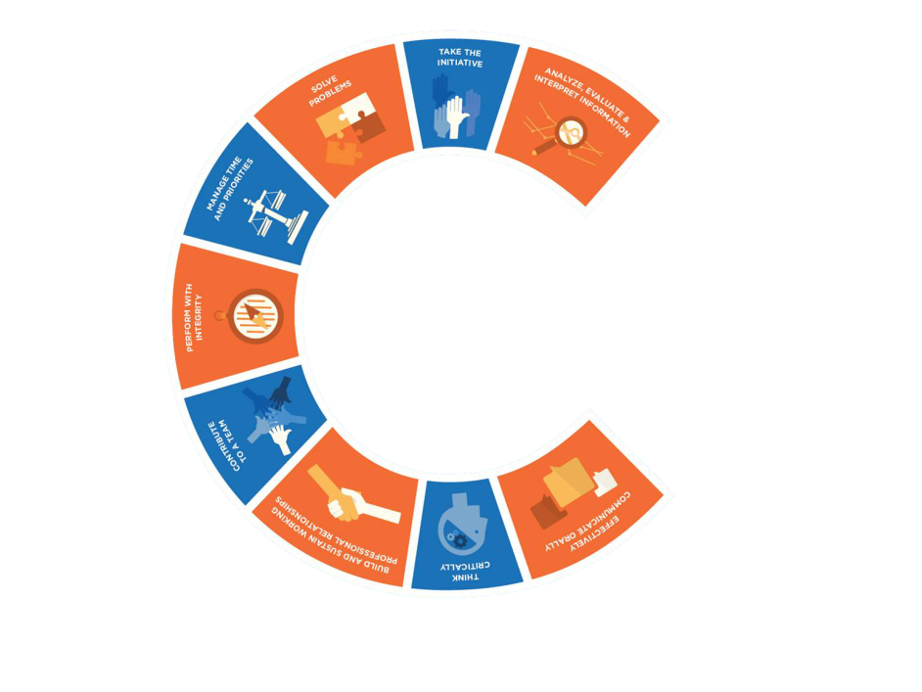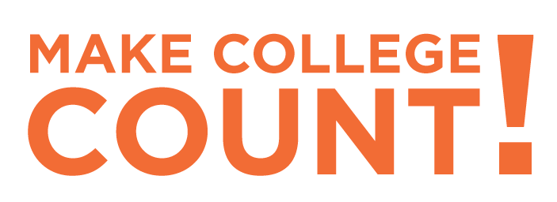

CHOOSE A CAREER PATH

CHOOSE A COLLEGE AND A MAJOR

Questions?

*For questions about the course itself, contact the Boise State University Career Center at career@boisestate.edu or*

*(208) 426-1747. Visit* [*career.boisestate.edu*](career.boisestate.edu) *to learn more about career planning and how to Make College Count!*

*For questions about Concurrent Enrollment or receiving money to pay for Concurrent Enrollment classes, speak with your school’s counselor or contact Concurrent Enrollment at concurrentenrollment@boisestate.edu or (208) 426-1709, or visit the Concurrent Enrollment website:* [*extendedstudies.boisestate.edu/concurrentenrollment*](extendedstudies.boisestate.edu/concurrentenrollment)

**YOU WILL BE EMPLOYABLE**

MAKE A PLAN TO ENSURE

*This course is designed to help you plan and prepare for a successful future. The rising cost of college and higher-than-ever employer expectations mean that your career preparation needs to begin NOW. This course will guide you through the process of choosing a career path that balances your interests, abilities, work values, and personality with the realities of the current job market. You will also learn what you'll need to do during your time in college (besides taking classes!) to become employable, and you will even begin learning the job search skills, such as strategic networking and personal branding that you'll need in the future.*

In this class, you will:

• Assess your interests, abilities, values, and personality traits, and identify characteristics of work environments that fit you

• Learn what careers exist and generate potential career options

• Learn where and how to research career options, and conduct in-depth research on a potential career path

• Obtain and use job market information in making your decision about a career path

• Research educational options and work on selecting a school and major appropriate to your career goals

• Learn what employers expect of college graduates today and how to ensure employability by making college count

• Create a personal career preparation plan

• Learn about modern hiring practices and job search strategies appropriate for the new economy

• Begin building your personal brand, and learn about managing your online presence

• Learn how to build a professional network as a student

• Learn how to write targeted resumes and cover letters and impress employers in an interview

*For more info:* ***CAREER.BOISESTATE.EDU/CAREERANDLIFEPLANNING***

• BOISE STATE UNIVERSITY CONCURRENT ENROLLMENT COURSE

• OFFERED ONLINE THROUGH THE IDAHO DIGITAL LEARNING ACADEMY

• EARN 2 COLLEGE CREDITS AND A LETTER GRADE IN ONE SEMESTER

ACAD 108: Career and Life Planning

Simply going to college and obtaining a degree

no longer guarantees employability.

Your choice of a college and major that are appropriate for your career goals,

along with the right skills, and relevant, hands-on experiences outside the classroom are all critical.

Engaging in the career planning process early will help you make better informed choices about your

post-secondary education, and “Go On” prepared to “Make College Count!”