Transferable Skills Activity- Faculty Instructions
Module 1: The Career Planning Process: An Overview

This activity will give students the opportunity to think about how they might be able to develop and demonstrate the critical professional skills though “student jobs” that many students consider to be valueless beyond a paycheck. You might remember that the terms “professional skills” and “transferable skills” can sometimes be used interchangeably, and in this case, we are using the term “transferable skills” because we are encouraging students to identify skills used in various types of jobs that can “transfer” to other types of jobs and professional positions.

Break the class into 6 groups. Assign each group ONE of the jobs listed below, which are common and general enough that most students, even if they have not worked that job, should have enough of an idea of what the job entails to participate in the activity:
- Server at a restaurant
- Fast food worker
- Retail sales associate
- Nanny/babysitter
- Summer camp counselor
- Construction worker, farm hand, or other manual labor job

Give each group ONE copy of the Part-Time Jobs and Transferable Skills worksheet to complete (included). They will first write the job they were assigned at the top. As a group, they will then brainstorm ways in which you might be able to develop or use this skill in that type of job. Remind them that these are the top 9 professional skills critical for employability in any career.

To help, suggest they consider these more specific questions:
- What tasks performed in this type of job would require this skill to complete? (For example, the “server” group might say that serving multiple tables simultaneously while keeping all customers happy requires being able to manage time and priorities effectively.)
- What situations might you find yourself in in this type of job that would require you to use this skill? (For example, the “server” group might say that when a customer is dissatisfied with their meal, it requires problem-solving skills to figure out how to make the customer happy while still following restaurant rules and policies.)

Groups do not have to come up with something for all 9 skills, but should try to come up with something for most of the skills.

Allot a certain amount of time for brainstorming. When time is up, have each group come to the front of the room and “present” to the class what they came up with for each skill. This will give the entire class an opportunity to learn about ways in which the critical professional skills can be developed or demonstrated in other types of jobs they may have had or will have while in college.

Part-Time Jobs and Transferable Skills

Our Group’s Job: _______________________________

How might you develop or use this skill in this type of job?

How might you develop or use this skill in this type of job?

How might you develop or use this skill in this type of job?

How might you develop or use this skill in this type of job?

How might you develop or use this skill in this type of job?

How might you develop or use this skill in this type of job?

How might you develop or use this skill in this type of job?

How might you develop or use this skill in this type of job?

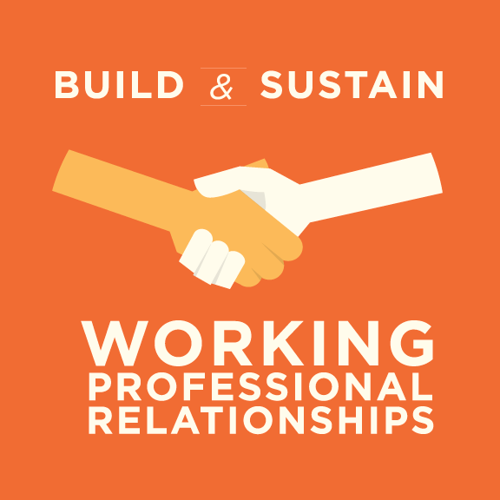
How might you develop or use this skill in this type of job?

