In-Class Module Completion Option- Faculty Instructions
Module 7: Career Preparation – Becoming Employable

There are benefits to having students complete the module independently, as the interactive activities contained in the module are designed to force students to think about their own beliefs, career goals, and how the material applies to their personal situation. Of course, there are benefits to having your class work through the module as a group as well. If you opt for in-class, group completion, it is recommended that you have students complete a follow-up assignment, such as reflective writing, that will force students to process the information on a personal level.

The basic idea of how to have your class complete the module as a group is simple. The video clip slides are easy – you can simply show those. For the activity and quiz slides, you will want to use those to facilitate either a class discussion or activity. The instructions below will provide you with a possible class discussion or activity to use with each interactive slide.

Discussion/Activity Options:

Activity Slides 1-3 (series of 3 T/F questions):
For each of the three questions, ask students to volunteer how they would answer and explain why. Encourage more students to share their thoughts by responding to answers with statements like “Who would agree with what he/she just said about _____? Tell me why you agree,” or “”Who would disagree with that statement? Tell me why you disagree.” When you feel that your class has adequately debated the issues involved, take a poll. Whichever answer (True or False) gets more votes, input that answer and then review the feedback with your class.

Activity Slide 4 (what you think you’ll need for your career):
Have your students complete the What I’ll Need for My Career worksheet (included). Optionally, once students have completed the worksheet, break them into small groups to share their responses and receive feedback from classmates. Instruct each student to share their responses and summarize their thought process behind what they choose to write down. After each student has shared, the rest of the group should provide feedback. (Do you agree with each of the things your classmate wrote down based on their career goal? What do you think should or could be added? If the student struggled to come up with anything for a particular category, help him or her brainstorm what might go there.) Once the groups are done, follow up with the entire class, reminding them that if they didn’t know the answers to one or more of the sections on the worksheet, or didn’t feel confident in the accuracy or completeness of their answers, they will need to do some research on the requirements for their career (very soon!) so they’ll know how to prepare.

Activity Slides 5-13 (skill slides):
When you first land on each skill slide, do not hover over the icon. Instead, pose the question on the slide (“Why does it matter to employers?”) to your class. Encourage them to think about each skill from a business/organization’s standpoint. In what ways could the skill level of employees in this particular area affect the organization’s mission and bottom line? Have students raise their hands and brainstorm. Once you’re satisfied with the responses, hover over the icon and read the explanation provided.

Next, read the Yes/No question on the slide and ask students to write down their response (for that skill only) on the Professional Skills Critical for Employability worksheet (included). Then have them write down (if yes), what things they have done that demonstrate they have that skill, or (if no), at least one thing they COULD do during college to allow them to demonstrate that skill on their resume.

Move on to the next skill and repeat the above process.

Activity Slide 14 (Opportunities to Gain Skills, Experience, and Contacts):
Have students complete the Opportunities to Gain Skills, Experience, and Contacts worksheet (included). Have students volunteer to share with the class which they felt were most and least important in their own career preparation, and why.

Review Slides:
There are a couple ways to approach these review questions. One option is to bring small prizes to class (like candy), or offer 1 point of extra credit (perhaps added to another assignment) to the first person to answer the question correctly (you decide whether to have students raise hands or just yell out the answer). Another option is to poll the class. There are a couple potential issues which could arise using the polling method, however. Some students may wait to see which answer the majority of the class raises their hands for, or they may not want to raise their hand for an unpopular answer. This approach also does not work very easily with the matching question. Another option is to have students write down their answer to each question on a blank sheet of paper (or the back of a worksheet). For the matching question, this would involve you reading each of the descriptions aloud and having students write down the name of the opportunity it describes. (Be aware that as you will be the one actually completing the question in the module, when you are ready to reveal the answers to the class, you will have to match everything correctly in order to move on.) Again, you might consider giving a prize to those who got every answer correct on all the review questions.
What I’ll need for My Career

Instructions: What have you already found out you need for the career you want to pursue? List a couple things you think are going to be most important under each section. If you haven’t started researching what you’ll need for your career yet, use these spaces to brainstorm what you think employers in your career field might want. If you haven’t chosen a career path yet, pick one you’re interested in or considering.

The career I plan to pursue is: __________________________________________________________________________

Education
What type of degree (associate's, bachelor's, master's, doctorate, etc.) and major or program of study is required for my career?

Skills
What are the most important skills I’ll need to develop?

Experience
What types of experiences outside the classroom will I need to have?

Contacts
What kinds of people will I need to have in my network in order to get a job in my field?

Professional Skills Critical for Employability
Yes
No
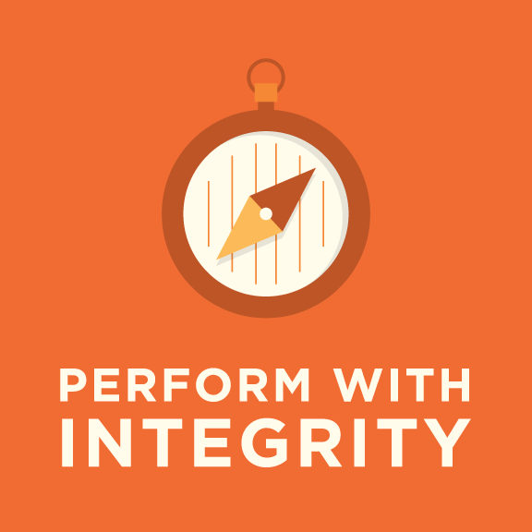
Have you already done something which could be listed on your resume that demonstrates you possess or have successfully used this skill outside the classroom?

If yes, what have you done that demonstrates this skill? If no, write down at least one thing you COULD do while in college that would allow you to demonstrate that skill on your resume.

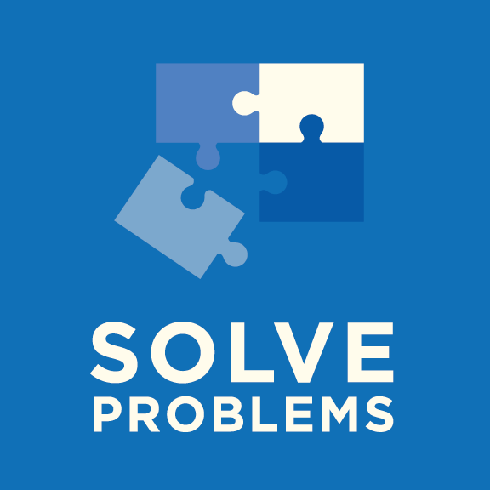
Have you already done something which could be listed on your resume that demonstrates you possess or have successfully used this skill outside the classroom?
Yes
No

If yes, what have you done that demonstrates this skill? If no, write down at least one thing you COULD do while in college that would allow you to demonstrate that skill on your resume.

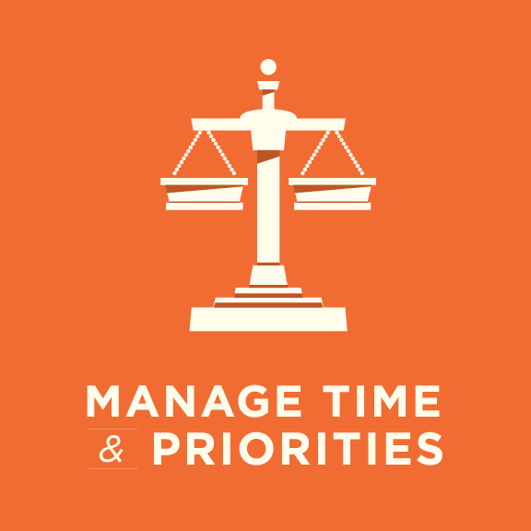
Have you already done something which could be listed on your resume that demonstrates you possess or have successfully used this skill outside the classroom?
Yes
No

If yes, what have you done that demonstrates this skill? If no, write down at least one thing you COULD do while in college that would allow you to demonstrate that skill on your resume.

Have you already done something which could be listed on your resume that demonstrates you possess or have successfully used this skill outside the classroom?
Yes
No

If yes, what have you done that demonstrates this skill? If no, write down at least one thing you COULD do while in college that would allow you to demonstrate that skill on your resume.

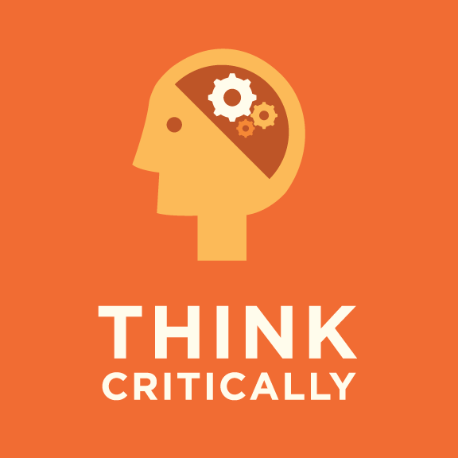
Have you already done something which could be listed on your resume that demonstrates you possess or have successfully used this skill outside the classroom?
Yes
No

If yes, what have you done that demonstrates this skill? If no, write down at least one thing you COULD do while in college that would allow you to demonstrate that skill on your resume.

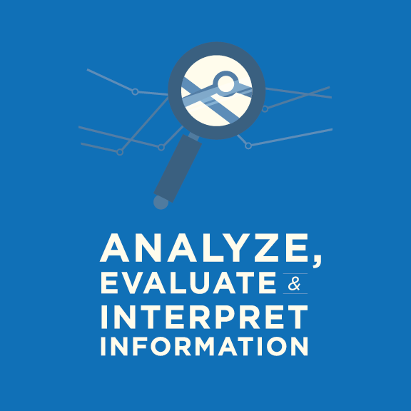
Have you already done something which could be listed on your resume that demonstrates you possess or have successfully used this skill outside the classroom?
Yes
No

If yes, what have you done that demonstrates this skill? If no, write down at least one thing you COULD do while in college that would allow you to demonstrate that skill on your resume.

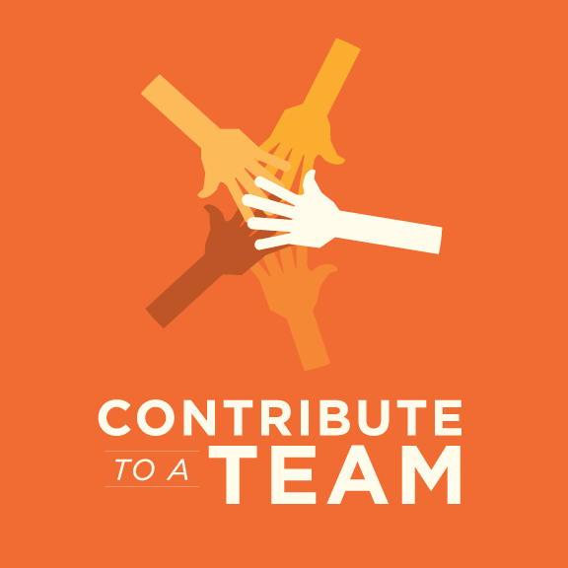
Have you already done something which could be listed on your resume that demonstrates you possess or have successfully used this skill outside the classroom?
Yes
No

If yes, what have you done that demonstrates this skill? If no, write down at least one thing you COULD do while in college that would allow you to demonstrate that skill on your resume.

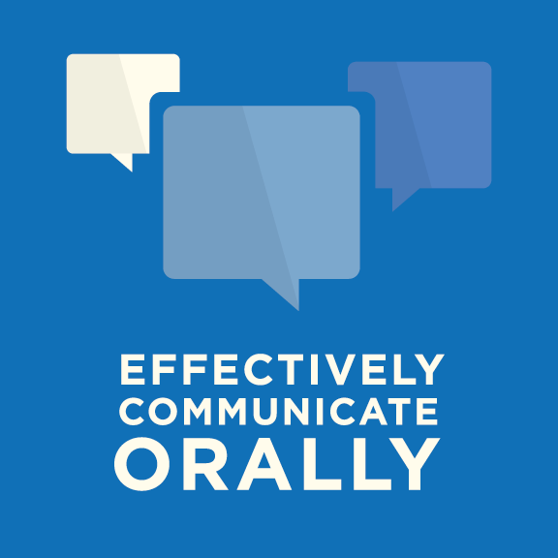
Have you already done something which could be listed on your resume that demonstrates you possess or have successfully used this skill outside the classroom?
Yes
No

If yes, what have you done that demonstrates this skill? If no, write down at least one thing you COULD do while in college that would allow you to demonstrate that skill on your resume.

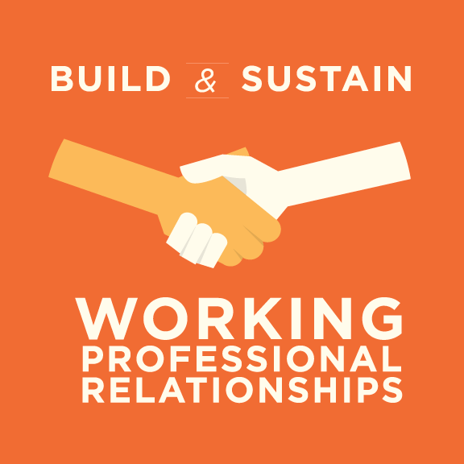
Have you already done something which could be listed on your resume that demonstrates you possess or have successfully used this skill outside the classroom?
Yes
No

If yes, what have you done that demonstrates this skill? If no, write down at least one thing you COULD do while in college that would allow you to demonstrate that skill on your resume.

Opportunities to Gain Skills, Experiences, and Contacts

Instructions: Think about this list of opportunities like a menu. You certainly do not have to participate in every one of these activities in order to be employable. It is important to be aware of everything that is available, so that you can select the opportunities that are the best fit for your career goals.

Now that you’ve learned a little about each of these opportunities to gain skills, experiences, and contacts, consider what you wrote down earlier in this module about what you thought was going to be most important to employers in your career field, and using that information, rank order how important you think each of these opportunities could be for you in preparing for your intended career. Rank each opportunity by writing a number 1-9 (1 being most important, 9 being least important) on the line next to that opportunity.

____________ |  | Internships
____________ |  | Volunteering
____________ |  | Service-Learning
____________ |  | Student Clubs and Organizations
____________ |  | Research
____________ |  | International Learning Opportunities
____________ |  | Jobs
____________ |  | Class Projects
____________ |  | Professional Organizations

