Marketing your Experiences and Education
These skills have been identified by employers across all sectors as critical to early success in the work place. Employers expect you to have these skills when you graduate from college. Use this worksheet to reflect on your experiences as a Boise State student and provide examples to illustrate how you gained or used the skill.
Take control of your future. You have the story, now articulate it.
Skills | Experiences | Examples (Anecdotes)
Analyze, evaluate & interpret information
Build and sustain working professional relationships
Contribute to a team
Communicate effectively orally
Manage time and priorities
Perform with integrity
Solve problems
Take the initiative
Think critically

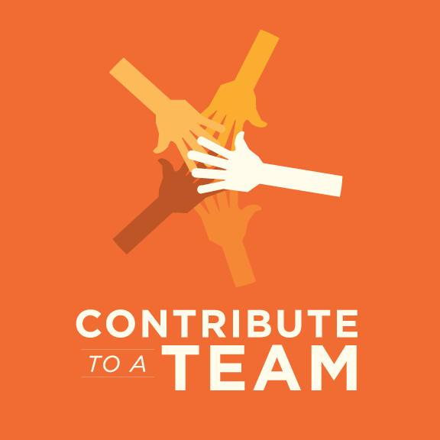
Teamwork, Your Group Project, and Your Career

“Contribute to a Team” is one of the top professional skills employers say is absolutely critical to employability. This worksheet will give you an opportunity to analyze the teamwork skills you utilized while completing this group project, and prepare you to share that information with employers.

1. What other skills did you have to utilize in this group project in order to work effectively with your team?

Skill:
Give an example of how you used this skill:
Skill:
Give an example of how you used this skill:
Skill:
Give an example of how you used this skill:

2. What challenges did you encounter in working with your team?

Challenge:
What skills did you have to use to overcome this challenge?
Challenge:
What skills did you have to use to overcome this challenge?

3. What were your successes or accomplishments in this project?

Accomplishment:
What skills does this accomplish “prove” that you have?
Accomplishment:
What skills does this accomplish “prove” that you have?
Accomplishment:
What skills does this accomplish “prove” that you have?

4. Putting it all together:
Employers want to know how you’ve successfully demonstrated the use of these critical skills, so it’s important that you know how to articulate this information to employers. Write a paragraph below that answers the following “question” using the information above: Describe a time you worked with a team and had to overcome challenges in order to accomplish the team’s objective. Use the STAR method for answering behavioral interview questions, making sure to include the Situation, the Task or problem, the Action you took, and the Result you achieved.

