When setting up the instructor(s) for a class, it's important to be aware that PeopleSoft considers them all 'primary instructors' by default. All primary instructors will show up then in Faculty180, MyInsights, and other reporting tools as receiving credit for teaching the class and on the course evaluation for the class.

If someone needs administrative access to the class, which allows them to view the roster and enter grades, but is not actually teaching the class, they should be set up as a secondary instructor. Secondary instructors will not show up in Faculty180 and the like or on course evaluations. (All instructors, primary and secondary, will be added to the Blackboard instance for the course and will have identical permissions there.)

Making an instructor secondary is done by including a message asking for this change in the highlighted box in the image below as you get ready to add the class.

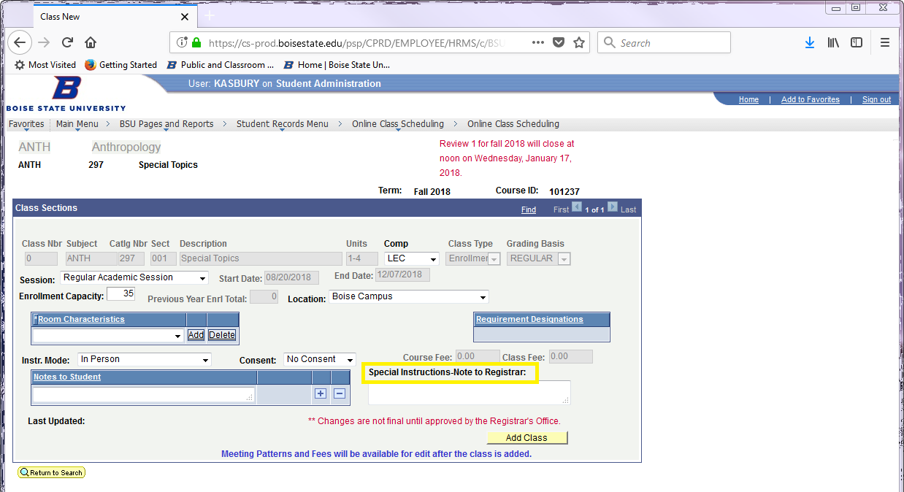

Note that the term "secondary instructor" is specific to PeopleSoft. It has nothing to do with someone being a co-instructor for the class and carrying a lighter load than the other instructor. **All instructors actually teaching the class should be left as primary instructors.**

If you need to add a class or make a change to a current class, use the links below. There are two forms, one for on campus classes (our class sections are 3 characters for sections and an alpha for labs) and one for classes that Extended Studies sections (their sections are always 4 characters).

https://secureforms.boisestate.edu/registrar/schedulechange-fallandspring/ for on campus sections.

https://secureforms.boisestate.edu/extendedstudies/change-request-form/ for Extended studies sections.