How to: Run the Validation Report
Step |  | Action
1 |  | From your my.boisestate.edu menu (Employee View), select Campus Solutions (PeopleSoft)
2 |  | At the top of the page type “Validation Reports” and select the Eyeglass
3 |  | Select Validation Reports  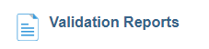
4 | Enter your Run Control ID & Click the Search Button. First-time users will need to Add a New Value.  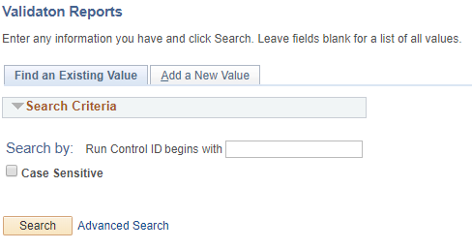
5 | Enter the 4-digit term, then click the Save button. Click the Run button. Select the eyeglass to find the term you want to review.  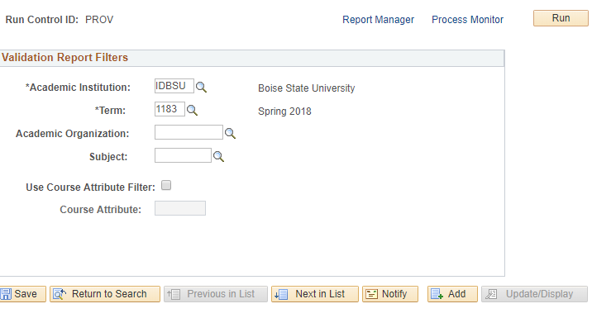
6 | Select OCS Class Validation Rpt. Click the OK button.  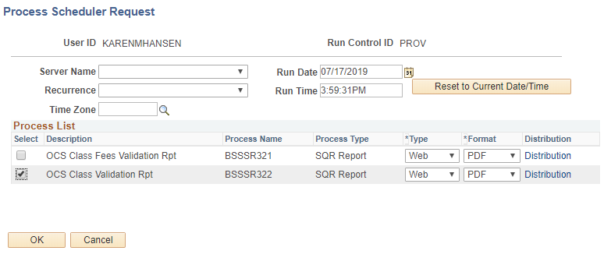
7 | Click Process Monitor 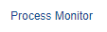
8 | Click the Refresh button. 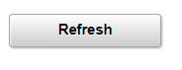
9 | Your report will be ready when Run Status says Success and Distribution Status says Posted. 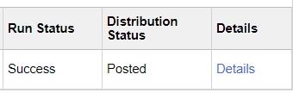
10 | Select Details
11 | Select View Log/Trace 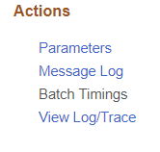
12 | Select file – .pdf or Excel 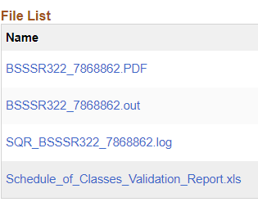
13 | You may receive a message that the file is uncorrupted or unsafe and asks if you want to open it. Select Yes.
14 | End of Procedure.

