How to: Run the Validation Report
Step |  | Action
1 |  | From your my.boisestate.edu menu, select Campus Solutions (PeopleSoft)
2 |  | Click on the NavBar located in the upper right corner of your screen
3 |  | Select Navigator
4 |  | Select BSU Pages and Reports
5 | Select Student Records Menu
6 | Select Online Class Scheduling
7 | Select Validation Reports
8 | Enter your Run Control ID & Click the Search Button. First-time users will need to Add a New Value.  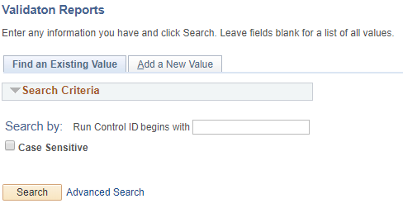
9 | Enter the 4-digit term, then click the Save button. Click the Run button.  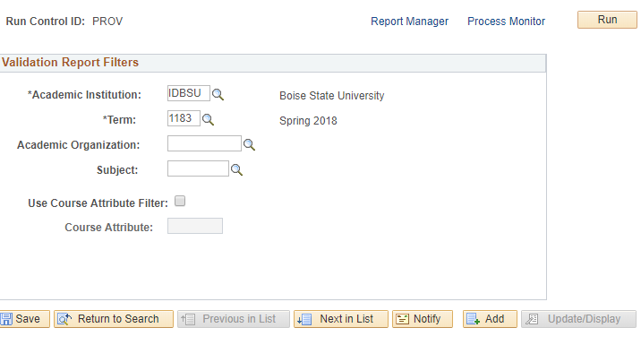
10 | Select OCS Class Validation Rpt. Click the OK button.  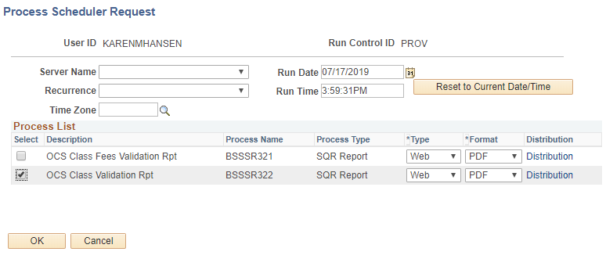
11 | Click Process Monitor 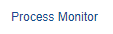
12 | Click the Refresh button. 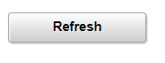
13 | Your report will be ready when Run Status says Success and Distribution Status says Posted. 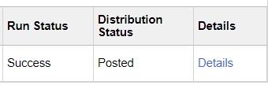
14 | Select Details
15 | Select View Log/Trace 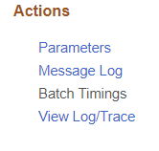
16 | Select file – .pdf or Excel 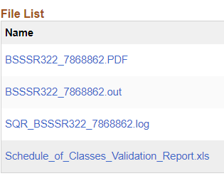
17 | You may receive a message that the file is uncorrupted or unsafe and asks if you want to open it. Select Yes.
18 | End of Procedure.

