How to: Run the Class/Course Fee Annual Report
Step |  | Action
1 |  | From your my.boisestate.edu menu, select “Reporting Services”
2 |  | Select “Login to MyInsights”  NOTE: To bypass the my.boisestate.edu, you may also navigate to: https://biinside.boisestate.edu/reports  You will be required to login
3 |  | Select Main Student Data Reports , Student Financials
4 |  | Select Course Fee Annual Report Expenses  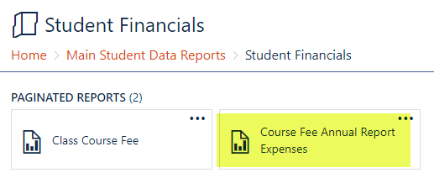
5 | The only year now accessible is 2018, but you will select your Fund Department CostCenter (FDCCC) from the drop down. Then select “View Report”  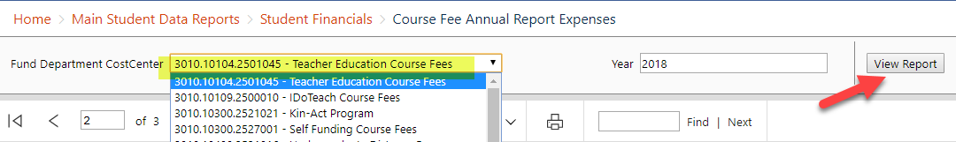
6 | Notice that there is more than one page to your report, and you may need to scroll through the report to see all pages.  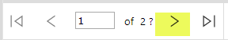
7 | You will also want to save the report to Excel to see it in it’s entirety:  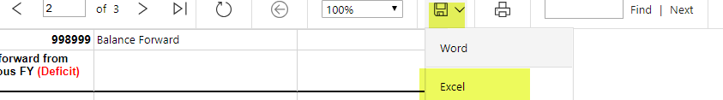
8 | The report has three sections: 1) Revenue/expense information for the FY; 2) the summary, discussion, and certification form you will need to complete; 3) the enrollment information.
9
10
11
12 | End of Procedure.

