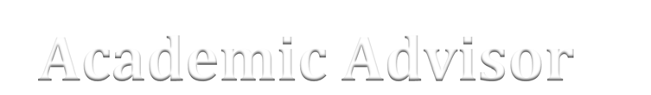

1. What are the Disciplinary Lens courses and which ones to I need to take?
2. What are the requirements for the major I’m considering?
3. Do classes have to be taken in sequence?
4. Can I change my major?
5. How can I get my advising hold removed?
6. What is Finish in Four?
7. How many classes should I take each semester?
8. How many credits do I need to be full time?
9. Can I test out of any classes?
10. What other resources are there I can take advantage of?
11. What happens if I drop a class?
12. Can I repeat a class?
13. What happens if I’m on Academic Probation?
14. What is SAP?
15. What can you tell me about getting a minor?

